Ansible Challenge
Create ci pipeline that will deploy and configure these VMs using terraform and ansible according following requirements
- Deploy 2 virtual machines using terraform.
  - first vm on Amazon linux, hostname: c8.local
  - second vm on ubuntu 21.04, hostname: u21.local
- As a result of terraform execution, dynamically create inventory for ansible
  - c8.local should be in the frontend group
  - u21.local should be in the backend group
- Create ansible playbook for c8.local and u21.local
- for linux OS playbook should apply the following changes
  - selinux: disable
  - firewalld: disable
- for frontend playbook group should install and configure nginx
  - nginx configuration should do proxying from port 80 on port 19999 to the
  - backend group
- for the backend group, the playbook must install the Netdata application from the
  - official repositories and run it on port 19999.

Target architecture
Jenkins CI Pipeline
Terraform → Dynamic inventory → Ansible
AWS EC2 instances
Frontend c8.local
Amazon Linux
Nginx :80
Reverse proxy
Backend u21.local
Ubuntu 21.04
Netdata :19999
Monitoring UI
Expected flow: Browser → Nginx on frontend port 80 → Netdata on backend port 19999.
One important note: Ubuntu 21.04 is end-of-life. Its official repositories are no longer normally available. We’ll first check whether your challenge environment provides an appropriate AMI. If the requirement is strict, we’ll address that constraint rather than silently changing the OS.
Step 1 — Verify the Jenkins environment
Run these commands on the machine where your Jenkins pipeline will execute. If Jenkins runs on your existing AWS Jenkins EC2 instance, connect to that instance first.
echo "===== OS ====="
cat /etc/os-release

echo "===== Terraform ====="
terraform -version

echo "===== Ansible ====="
ansible --version

echo "===== AWS CLI ====="
aws --version

echo "===== Git ====="
git --version

echo "===== Java ====="
java -version
Check AWS credentials and region access:
aws sts get-caller-identity
aws configure get region
If Jenkins uses an EC2 IAM role, you do not need to configure permanent AWS access keys; use the role with the required EC2 permissions instead.
What we need to verify
- Terraform is installed.
- Ansible is installed.
- AWS CLI can authenticate successfully.
- Jenkins can run shell commands on its build agent.
- The AWS region is known.
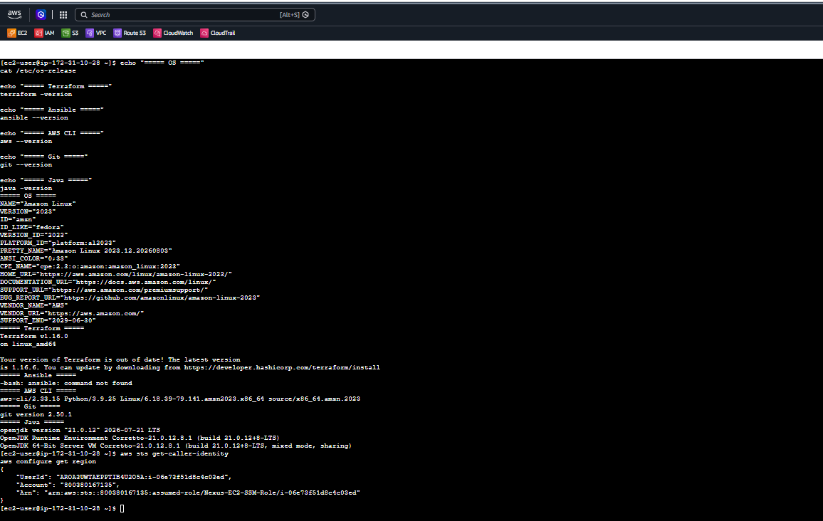
Step 2 — Install Ansible on Amazon Linux 2023
Run these commands on your current EC2 instance (ec2-user@ip-172-31-10-28).
2.1 Update package metadata
sudo dnf makecache
2.2 Install Ansible
sudo dnf install ansible-core -y
2.3 Verify installation
ansible --version
ansible-playbook --version
Both commands should display the installed Ansible version.
If ansible-core is unavailable, don't install random packages; send me the error so we can select the appropriate installation method.
Step 3 — Create the project directory
After Ansible installs successfully, run:
mkdir -p ~/nginx-netdata-ci/{terraform,ansible}
cd ~/nginx-netdata-ci
Verify the structure:
find . -maxdepth 2 -type d
Expected output:
.
./terraform
./ansible
We'll put the Terraform files in terraform/, Ansible inventory and playbooks in ansible/, and later add a Jenkinsfile in the project root.
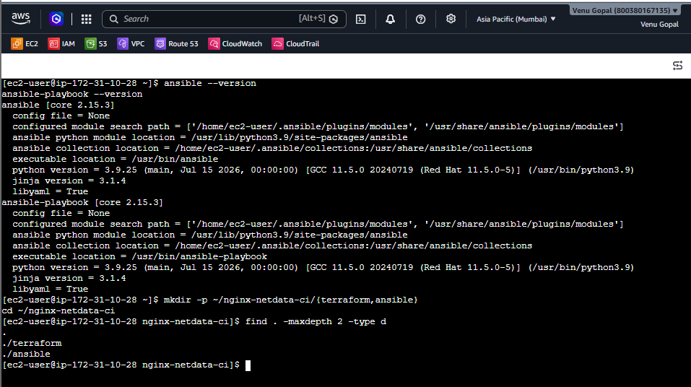
Step 4 — Prepare Terraform configuration
4.1 Go to the Terraform directory
cd ~/nginx-netdata-ci/terraform
4.2 Confirm the AWS region
Your console shows Mumbai, so use ap-south-1.
export AWS_DEFAULT_REGION=ap-south-1
Verify:
echo $AWS_DEFAULT_REGION
aws sts get-caller-identity
4.3 Check whether you can list EC2 instances
aws ec2 describe-instances \
--region ap-south-1 \
--max-results 5
If you receive UnauthorizedOperation, your IAM role needs additional permissions. Continue with the file preparation below, but don't run terraform apply until permissions are fixed.
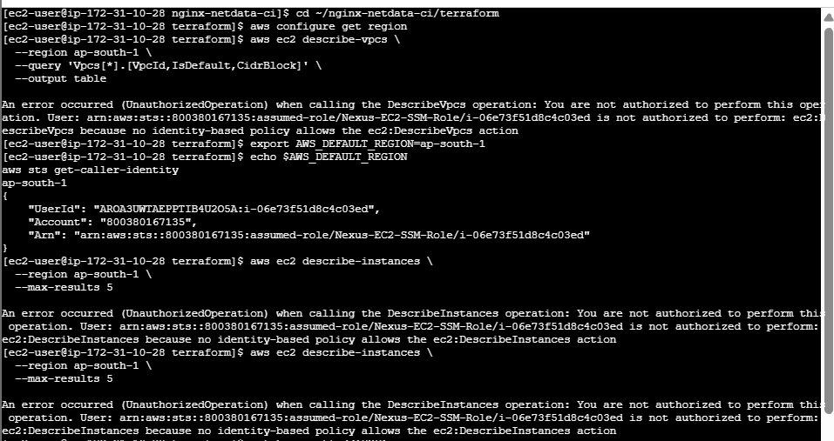
4.4 Create the Terraform configuration file
cat > main.tf <<'EOF'
terraform {
required_version = ">= 1.5.0"

required_providers {
aws = {
source = "hashicorp/aws"
version = "~> 6.0"
}
}
}

provider "aws" {
region = "ap-south-1"
}

data "aws_vpc" "default" {
default = true
}

data "aws_subnets" "default" {
filter {
name = "vpc-id"
values = [data.aws_vpc.default.id]
}
}

output "vpc_id" {
value = data.aws_vpc.default.id
}

output "subnet_ids" {
value = data.aws_subnets.default.ids
}
EOF
This is a preliminary configuration to discover the default VPC and subnets. It does not create any resources.
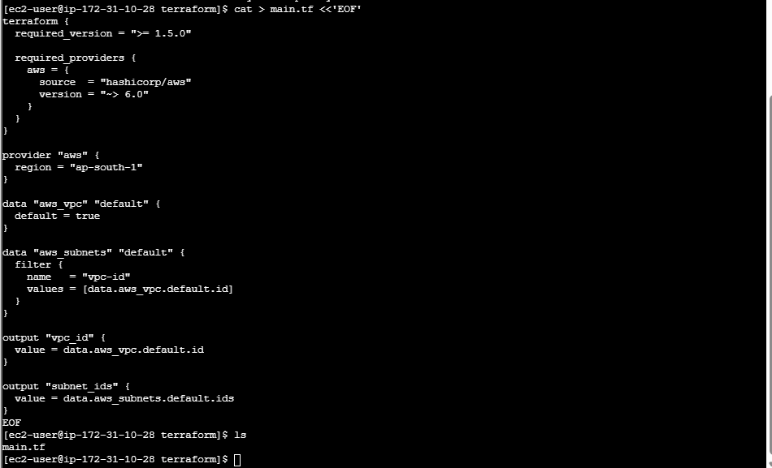
4.5 Initialize Terraform
terraform init
Then validate the configuration:
terraform validate
4.6 Check the VPC discovery plan
terraform plan
The plan may fail because the IAM role lacks ec2:DescribeVpcs or related permissions. If so, that is expected until the role policy is updated.
Let's continue from your current directory without repeating completed steps.
Step 4.7 — Check the Terraform files
Run:
cd ~/nginx-netdata-ci/terraform
ls -l
Confirm that main.tf exists.
Step 4.8 — Attach permissions to the EC2 IAM role
- Open IAM → Roles → Nexus-EC2-SSM-Role.
- Click Add permissions → Attach policies.
- Search for AmazonEC2FullAccess.
- Since this is a broad policy, use it only if this is your own lab account and you accept the additional EC2 permissions it grants. Otherwise, use a dedicated policy restricted to the lab resources.
- If you are authorized and choose the broad policy, select it and click Add permissions.
Keep AmazonSSMManagedInstanceCore attached.
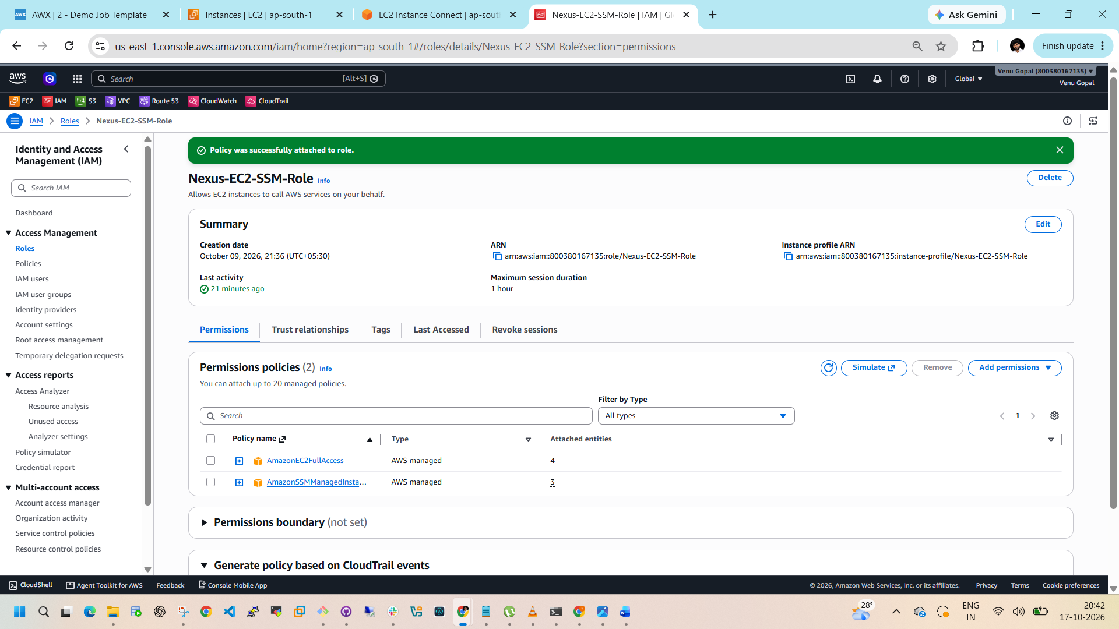
Verify the change
Return to your EC2 terminal and run:
aws ec2 describe-instances \
--region ap-south-1 \
--max-results 5
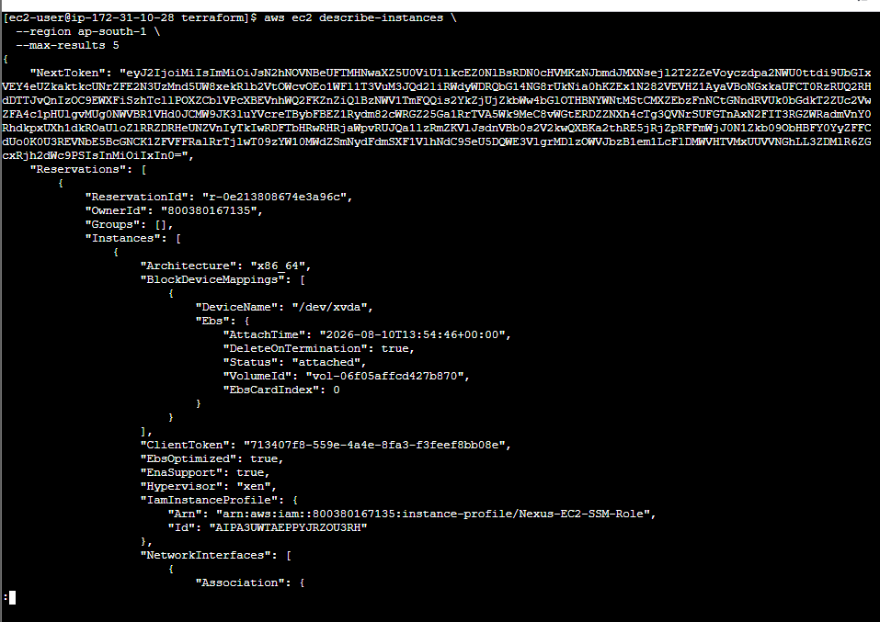
If it succeeds, run:
aws ec2 describe-vpcs \
--region ap-south-1 \
--query 'Vpcs[*].[VpcId,IsDefault,CidrBlock]' \
--output table
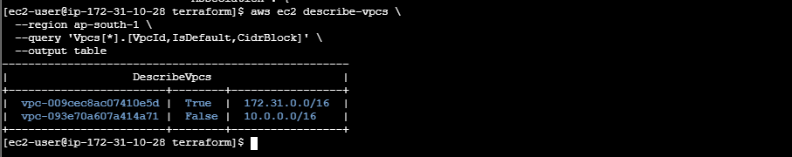
Continue Terraform configuration
1. Check subnet access
Run:
aws ec2 describe-subnets \
--region ap-south-1 \
--query 'Subnets[*].[SubnetId,VpcId,AvailabilityZone,MapPublicIpOnLaunch]' \
--output table \
--no-cli-pager
2. Check Ubuntu 21.04 AMI availability
aws ec2 describe-images \
--region ap-south-1 \
--owners 099720109477 \
--filters \
'Name=name,Values=ubuntu/images/hvm-ssd/ubuntu-hirsute-21.04-amd64-server-*' \
'Name=architecture,Values=x86_64' \
--query 'Images[*].[ImageId,Name,CreationDate,State]' \
--output table \
--no-cli-pager
Ubuntu 21.04 is end-of-life, so this search might return an empty table.
3. Verify the Terraform files
cd ~/nginx-netdata-ci/terraform
ls -l
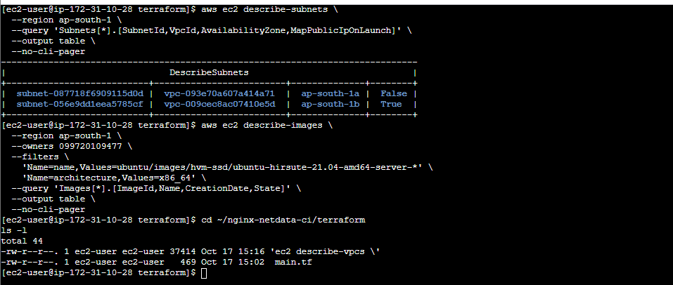
Step 4.9 — Clean up and verify Terraform
1. Remove the accidental file
Run:
cd ~/nginx-netdata-ci/terraform
rm -i 'ec2 describe-vpcs \'
If prompted to remove it, enter y.
2. Check your current Terraform configuration
cat main.tf
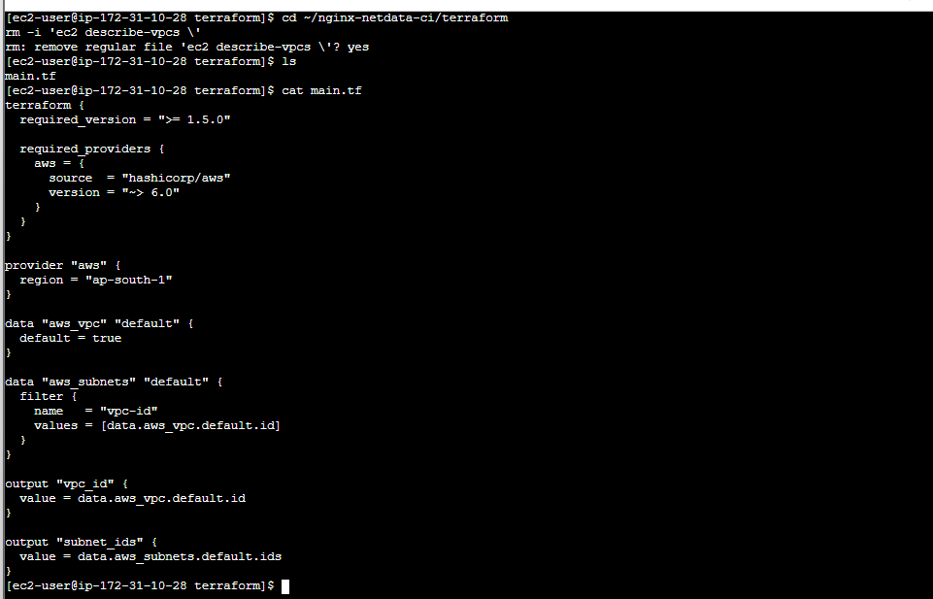
3. Check Terraform initialization and validation
terraform init
terraform validate
Don't run terraform apply yet.
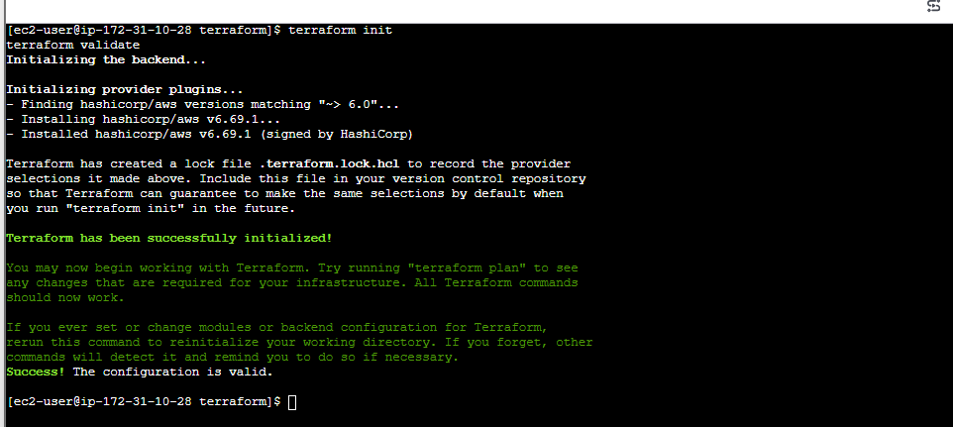
Step 4.10 — Find an available Ubuntu AMI
Because Ubuntu 21.04 is end-of-life, the official AMI search returned no results. Let's check Ubuntu 22.04 as a fallback, but we won't change your requirement without your approval.
aws ec2 describe-images \
--region ap-south-1 \
--owners 099720109477 \
--filters \
'Name=name,Values=ubuntu/images/hvm-ssd/ubuntu-jammy-22.04-amd64-server-*' \
'Name=state,Values=available' \
'Name=architecture,Values=x86_64' \
--query 'sort_by(Images,&CreationDate)[-3:].[ImageId,Name,CreationDate]' \
--output table \
--no-cli-pager
Also check Amazon Linux 2023:
aws ec2 describe-images \
--region ap-south-1 \
--owners amazon \
--filters \
'Name=name,Values=al2023-ami-2023.*-kernel-*-x86_64' \
'Name=state,Values=available' \
--query 'sort_by(Images,&CreationDate)[-3:].[ImageId,Name]' \
--output table \
--no-cli-pager
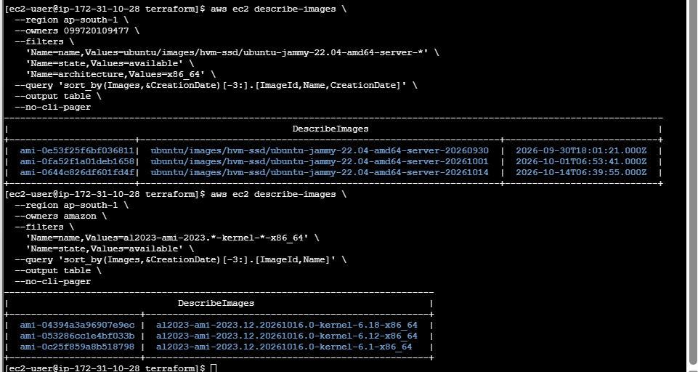

Step 5 — Create Terraform configuration for both VMs
We'll configure:
- c8.local — Amazon Linux 2023, frontend.
- u21.local — Ubuntu 22.04 fallback, backend.
- A security group for Nginx and Netdata.
- An automatically generated Ansible inventory.
5.1 Create variables.tf
Run from your current directory:
cd ~/nginx-netdata-ci/terraform

cat > variables.tf <<'EOF'
variable "aws_region" {
description = "AWS deployment region"
type = string
default = "ap-south-1"
}

variable "key_name" {
description = "Existing EC2 key pair name"
type = string
default = "Jenkins"
}

variable "frontend_instance_type" {
type = string
default = "t3.micro"
}

variable "backend_instance_type" {
type = string
default = "t3.micro"
}
EOF
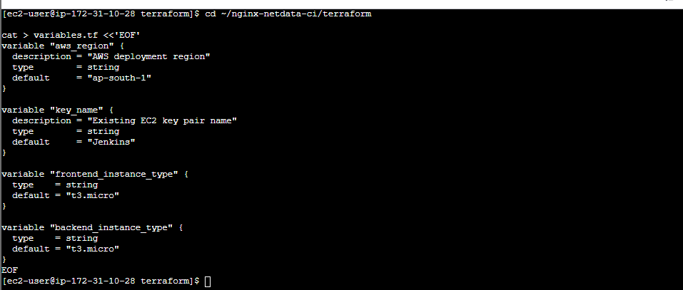
5.2 Create instances.tf
This configuration creates two instances and their security group. The frontend accepts HTTP traffic on port 80; the backend's Netdata port is accessible only from the frontend security group.
cat > instances.tf <<'EOF'
data "aws_ami" "amazon_linux" {
most_recent = true
owners = ["amazon"]

filter {
name = "name"
values = ["al2023-ami-2023.*-kernel-6.12-x86_64"]
}

filter {
name = "architecture"
values = ["x86_64"]
}

filter {
name = "state"
values = ["available"]
}
}

resource "aws_security_group" "app" {
name = "nginx-netdata-lab-sg"
description = "Security group for frontend and backend"
vpc_id = data.aws_vpc.default.id

ingress {
description = "HTTP frontend"
from_port = 80
to_port = 80
protocol = "tcp"
cidr_blocks = ["0.0.0.0/0"]
}

ingress {
description = "Netdata from frontend only"
from_port = 19999
to_port = 19999
protocol = "tcp"
self = true
}

ingress {
description = "SSH for lab administration"
from_port = 22
to_port = 22
protocol = "tcp"
cidr_blocks = ["0.0.0.0/0"]
}

egress {
from_port = 0
to_port = 0
protocol = "-1"
cidr_blocks = ["0.0.0.0/0"]
}

tags = {
Name = "nginx-netdata-lab-sg"
}
}

resource "aws_instance" "frontend" {
ami = data.aws_ami.amazon_linux.id
instance_type = var.frontend_instance_type
subnet_id = data.aws_subnets.default.ids[0]
vpc_security_group_ids = [aws_security_group.app.id]
key_name = var.key_name
associate_public_ip_address = true

tags = {
Name = "c8.local"
Hostname = "c8.local"
Role = "frontend"
}
}

resource "aws_instance" "backend" {
ami = "ami-0644c826df601fd4f"
instance_type = var.backend_instance_type
subnet_id = data.aws_subnets.default.ids[0]
vpc_security_group_ids = [aws_security_group.app.id]
key_name = var.key_name
associate_public_ip_address = true

tags = {
Name = "u21.local"
Hostname = "u21.local"
Role = "backend"
}
}

resource "local_file" "ansible_inventory" {
filename = "${path.module}/../ansible/inventory.ini"

content = <<-EOT
[frontend]
c8.local ansible_host=${aws_instance.frontend.public_ip} ansible_user=ec2-user

[backend]
u21.local ansible_host=${aws_instance.backend.public_ip} ansible_user=ubuntu

[all:vars]
ansible_python_interpreter=auto_silent
EOT
}
EOF
Important: This uses the exact Ubuntu 22.04 AMI ID you verified in Mumbai. AMI IDs are region-specific. The security group allows SSH from anywhere for this lab; restrict port 22 to your own public IP before using it beyond a temporary exercise.
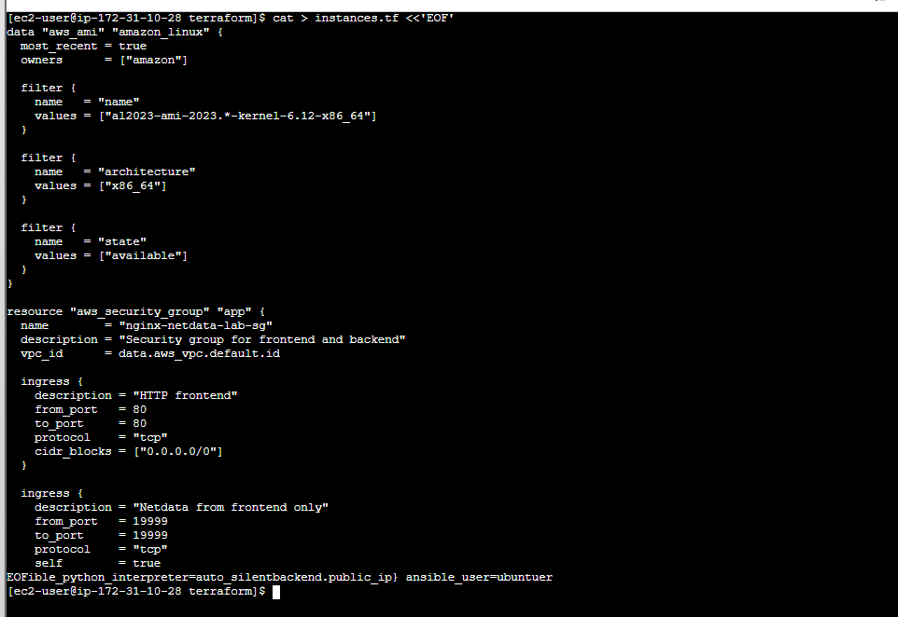
5.3 Replace main.tf
Your current main.tf already contains the VPC and subnet data sources. We'll keep it as-is for now, but the AWS provider must use the region variable. Run:
cat > main.tf <<'EOF'
terraform {
required_version = ">= 1.5.0"

required_providers {
aws = {
source = "hashicorp/aws"
version = "~> 6.0"
}

local = {
source = "hashicorp/local"
version = "~> 2.0"
}
}
}

provider "aws" {
region = var.aws_region
}

data "aws_vpc" "default" {
default = true
}

data "aws_subnets" "default" {
filter {
name = "vpc-id"
values = [data.aws_vpc.default.id]
}
}

output "frontend_public_ip" {
value = aws_instance.frontend.public_ip
}

output "backend_public_ip" {
value = aws_instance.backend.public_ip
}
EOF
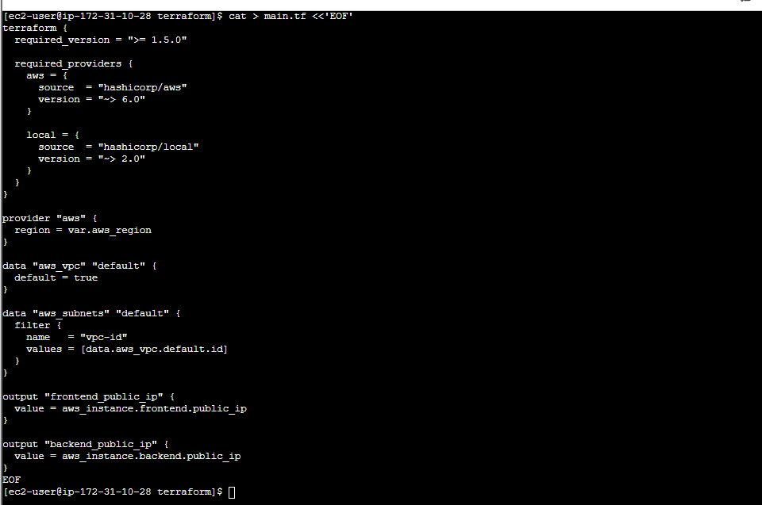
5.4 Initialize and validate
terraform fmt
terraform init
terraform validate
Expected validation result:
Success! The configuration is valid.
Then generate the execution plan:
terraform plan
Do not apply yet. We need to review the plan and ensure the IAM role can create the resources.
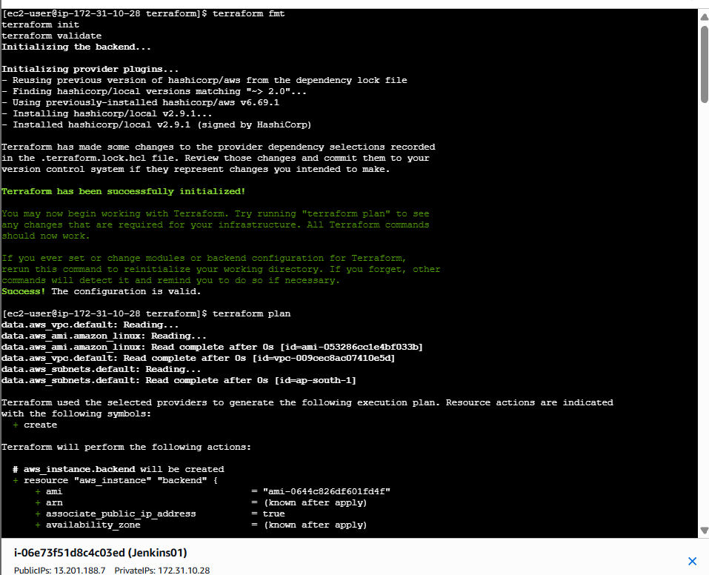
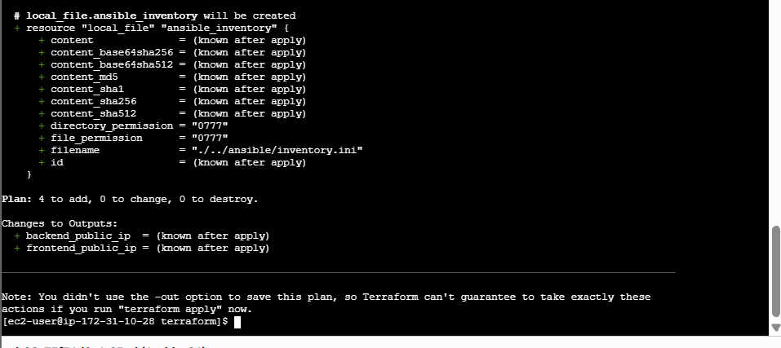
Step 5.5 — Verify the generated configuration files
ls -l
ls -l ../ansible
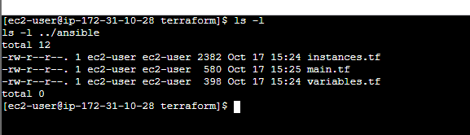
Step 5.6 — Fix SSH access before deployment
First, return to the Terraform directory:
cd ~/nginx-netdata-ci/terraform
Check the public IP you will use for SSH access:
curl -s https://checkip.amazonaws.com
Note the IP address returned. Then edit instances.tf:
vi instances.tf
Find the SSH ingress block:
ingress {
description = "SSH for lab administration"
from_port = 22
to_port = 22
protocol = "tcp"
cidr_blocks = ["0.0.0.0/0"]
}
Replace 0.0.0.0/0 with your IP followed by /32. For example, if your IP were 203.0.113.10, use:
cidr_blocks = ["203.0.113.10/32"]
Save and exit: press Esc, type :wq, then press Enter.
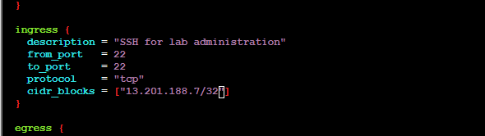
Step 5.7 — Revalidate the plan
Run:
terraform fmt
terraform validate
terraform plan
Expected result:
Plan: 4 to add, 0 to change, 0 to destroy.
The SSH rule will now be restricted to your IP.
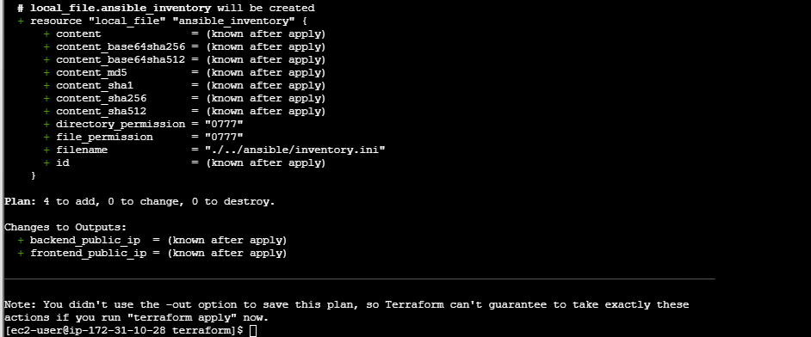
Step 5.8
Before applying, let's verify whether the SSH rule exists in your configuration.
Run this command:
cd ~/nginx-netdata-ci/terraform

grep -n -A7 -B2 'from_port.*22\|SSH for lab' instances.tf
- If it displays an SSH ingress rule, we'll restrict it to your public IP.
- If it displays nothing, we'll leave the configuration unchanged for now and review the security group.
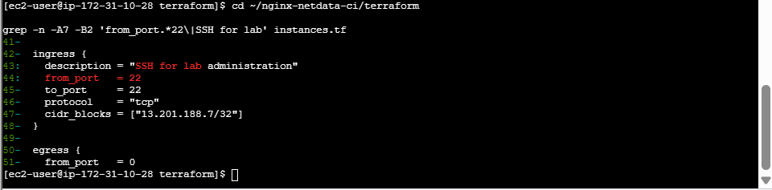

Step 5.9 — Apply Terraform
Your plan showed 4 to add, 0 to change, 0 to destroy. Now run:
cd ~/nginx-netdata-ci/terraform
terraform plan
If the plan still shows only the expected four resources to create, run:
terraform apply
Terraform will display the plan and ask for confirmation:
Do you want to perform these actions?
Enter a value:
Type:
yes
Wait until Terraform reports:
Apply complete! Resources: 4 added, 0 changed, 0 destroyed.
Important: If Terraform reports an IAM permission error or any unexpected resource changes, stop and send me the error rather than retrying blindly.
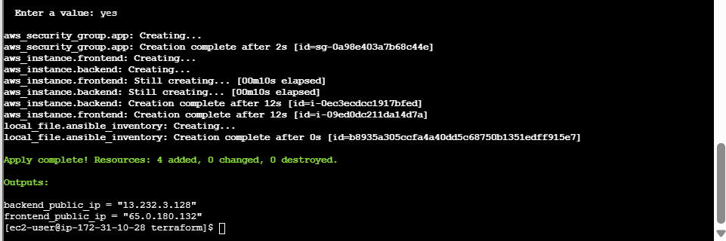
Step 5.10 — Verify the deployment
After a successful apply, run:
terraform output
Then check the generated inventory:
cat ../ansible/inventory.ini
It should contain two groups:
- [frontend] — c8.local
- [backend] — u21.local
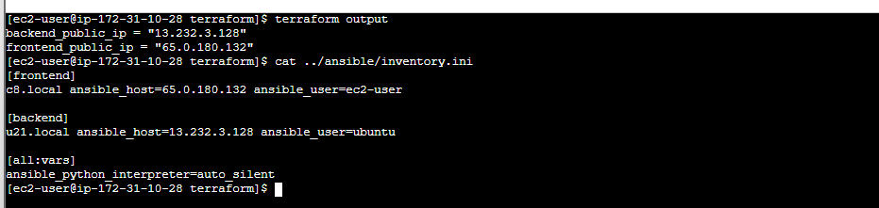
Step 6 — Verify the instances and inventory
Run these commands from your current terminal.
6.1 Check Terraform outputs
cd ~/nginx-netdata-ci/terraform
terraform output
Expected public IPs:
VM | Public IP | Group
c8.local | 65.0.180.132 | frontend
u21.local | 13.232.3.128 | backend
6.2 Check the generated Ansible inventory
cat ~/nginx-netdata-ci/ansible/inventory.ini
It should contain:
[frontend]
c8.local ansible_host=65.0.180.132 ansible_user=ec2-user

[backend]
u21.local ansible_host=13.232.3.128 ansible_user=ubuntu

[all:vars]
ansible_python_interpreter=auto_silent
6.3 Check that both instances are running
aws ec2 describe-instances \
--region ap-south-1 \
--instance-ids i-09ed0dc211da14d7a i-0ec3ecdcc1917bfed \
--query 'Reservations[].Instances[].[Tags[?Key==`Name`]|[0].Value,State.Name,PrivateIpAddress,PublicIpAddress]' \
--output table \
--no-cli-pager
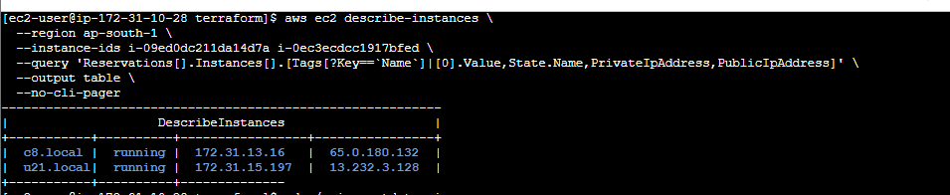
Step 7.1 — Transfer Jenkins.pem to the controller
Step 1: Open Session Manager
- AWS Console → EC2 → Instances.
- Select your controller instance (Jenkins01).
- Click Connect → Session Manager → Connect.
- Confirm the terminal prompt is on the controller.
Step 2: Check AWS CLI and S3 access
Run these commands in the controller's Session Manager terminal:
cd ~/nginx-netdata-ci
aws sts get-caller-identity
aws s3 ls
The first command should show the controller's AWS identity. The second checks whether the attached role can list S3 buckets.
Step 3: Choose the secure transfer method
Because your Jenkins.pem private key is on your Windows computer, Session Manager cannot directly read it from your Downloads folder. We need a secure transfer path.
Recommended: Use a private S3 bucket temporarily, with access restricted to your AWS account and controller role. Do not upload the key to a public bucket or paste its contents into chat.
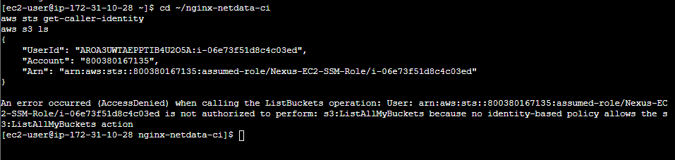
Step 7.2 — Check SSM and available transfer tools
Step 7.2 — Next check on Windows
Open Windows PowerShell on the computer where Jenkins.pem is saved and run:
Test-Path "$env:USERPROFILE\Downloads\Jenkins.pem"
If it returns True, run:
Get-Item "$env:USERPROFILE\Downloads\Jenkins.pem" |
Select-Object FullName, Length
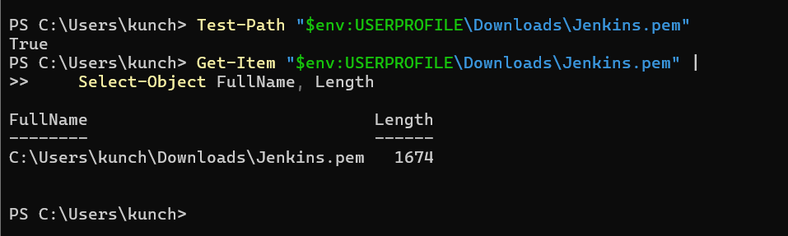
Step 7.3 — Create the S3 bucket
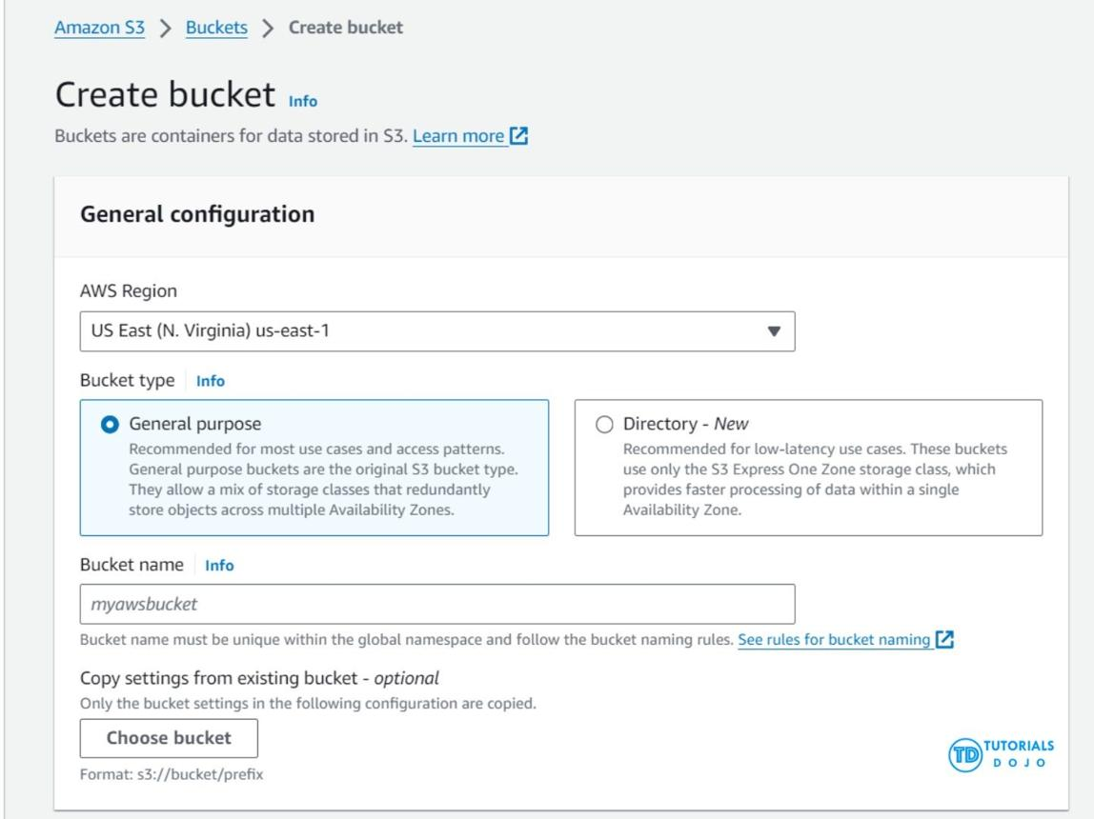
1. AWS Region
Select Asia Pacific (Mumbai) — ap-south-1.
2. Bucket type
Select General purpose.
3. Bucket namespace
Select Account Regional namespace (recommended) if that option is available.
4. Bucket name
Enter this name:
venu-jenkins-key-transfer-800380167135-20261017
If the console rejects it, add a few random lowercase letters or digits to make it unique.
5. Copy settings from existing bucket
Leave this blank.
Before clicking Create bucket
Scroll down and confirm these settings:
- Object Ownership: ACLs disabled (recommended).
- Block Public Access: Keep all four options enabled.
- Bucket Versioning: Disabled is fine for this temporary lab.
- Default encryption: Keep the default encryption enabled.
Then click Create bucket.
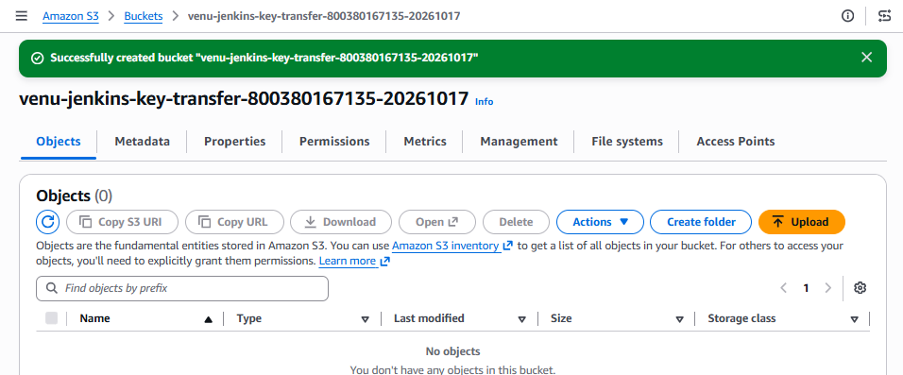
Step 7.4 — Add restricted S3 permissions to the controller role
Part A — Open the IAM role
- Open AWS Console → IAM → Roles.
- Select Nexus-EC2-SSM-Role.
- Click Permissions → Add permissions → Create inline policy.
- Select the JSON tab.
- Replace the existing JSON with the following policy.

{
"Version": "2012-10-17",
"Statement": [
{
"Sid": "TemporaryKeyTransferBucketAccess",
"Effect": "Allow",
"Action": [
"s3:ListBucket"
],
"Resource": "arn:aws:s3:::venu-jenkins-key-transfer-800380167135-20261017"
},
{
"Sid": "TemporaryKeyTransferObjectAccess",
"Effect": "Allow",
"Action": [
"s3:GetObject",
"s3:PutObject",
"s3:DeleteObject"
],
"Resource": "arn:aws:s3:::venu-jenkins-key-transfer-800380167135-20261017/*"
}
]
}
- Click Next.
- Set the policy name to TemporaryJenkinsKeyTransfer.
- Click Create policy.
This policy limits S3 access to the bucket you just created.
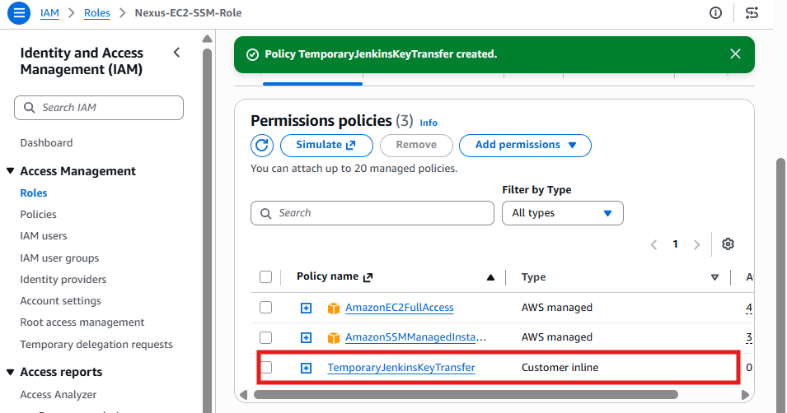
Step 7.5 — Verify S3 access from the controller
Return to your controller's Session Manager terminal and run these exact commands:
aws s3api head-bucket \
--bucket venu-jenkins-key-transfer-800380167135-20261017 \
--region ap-south-1
Then run:
aws s3 ls s3://venu-jenkins-key-transfer-800380167135-20261017/ \
--region ap-south-1
Expected result: The commands succeed, and the bucket listing is empty.
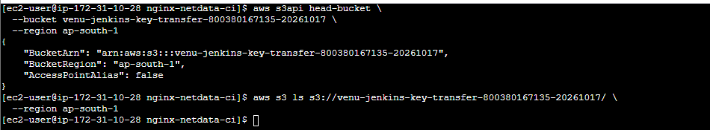
Step 7.6 — Prepare the private key on Windows
We'll transfer the key without making the bucket public.
First, open Windows PowerShell and run this command to confirm the key's permissions:
$key = "$env:USERPROFILE\Downloads\Jenkins.pem"
icacls $key
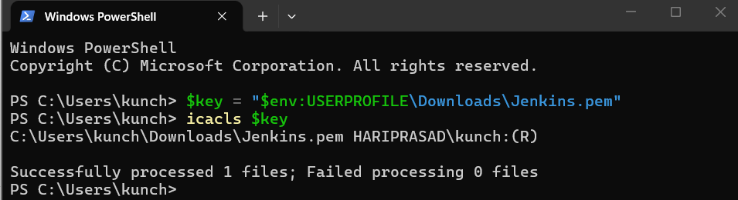
Step 7.7 — Transfer the key securely
Rather than store your SSH private key in S3, let's use AWS Systems Manager port forwarding or another approved transfer method. Your bucket is ready, but we don't need to upload the private key to it.
First, let's check whether the controller can download files from an S3 presigned URL and whether your Windows AWS CLI is configured.
In Windows PowerShell, run:
aws sts get-caller-identity
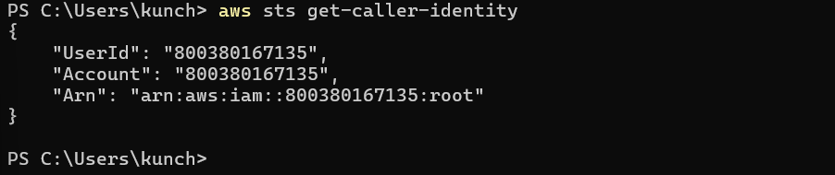
Step 7.8 — Check whether Windows can connect to the controller
In Windows PowerShell, run:
Test-NetConnection 13.201.188.7 -Port 22
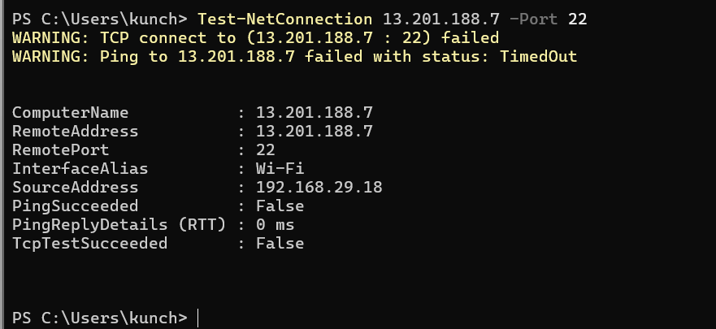
Step 7.9 — Transfer the key without opening SSH to Windows
The controller can access your private S3 bucket, so we can use a temporary transfer route. However, your Windows AWS CLI is authenticated as the root user, which is not recommended for this task.
Let's take the safer route: use AWS Console to check whether the controller has a suitable existing SSM connection and then transfer the key through a controlled channel.
First, verify the controller's security group
- Open AWS Console → EC2 → Instances.
- Select your controller instance (i-06e73f51d8c4c03ed).
- Open the Security tab.
- Click the attached security group.
- Inspect Inbound rules.
Don't add any new inbound rules yet.
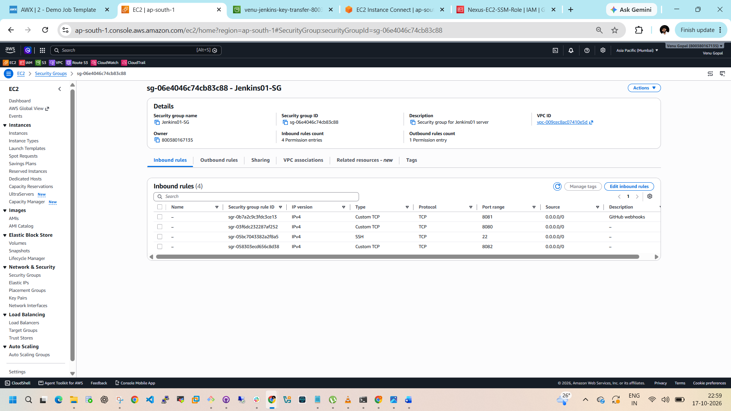
Step 7.10 — Secure the controller's SSH rule
Current rule to change
Type: SSH · Port: 22 · Source: 0.0.0.0/0
- On the page you shared, click Edit inbound rules.
- Find the SSH — TCP — 22 rule.
- Change the Source from Anywhere-IPv4 (0.0.0.0/0) to My IP.
- Confirm it displays your current public IP with /32.
- Click Save rules.
Keep the rules for ports 8080, 8081, and 8082 unchanged for now so we don't disrupt your Jenkins lab.
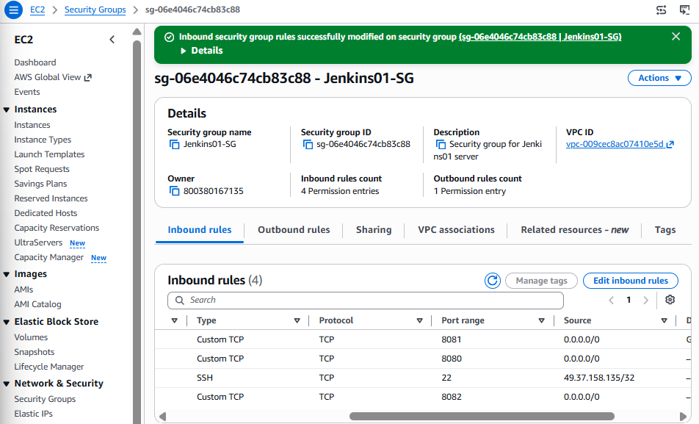
Step 7.11 — Verify the S3 transfer path
Return to your controller's Session Manager terminal and run:
aws s3 ls s3://venu-jenkins-key-transfer-800380167135-20261017/ \
--region ap-south-1
Then run:
aws sts get-caller-identity
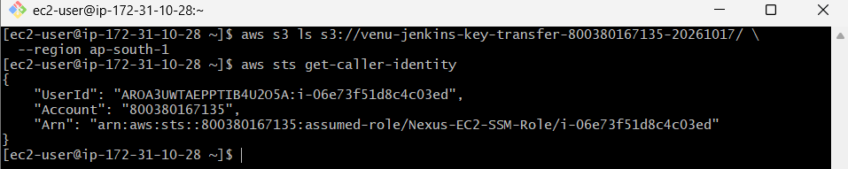
Step 7.12 — Create a restricted IAM policy
- Open AWS Console → IAM → Policies.
- Click Create policy → JSON.
- Paste this policy:

{
"Version": "2012-10-17",
"Statement": [
{
"Sid": "ListTemporaryTransferBucket",
"Effect": "Allow",
"Action": [
"s3:ListBucket"
],
"Resource": "arn:aws:s3:::venu-jenkins-key-transfer-800380167135-20261017"
},
{
"Sid": "TransferTemporaryKeyObject",
"Effect": "Allow",
"Action": [
"s3:PutObject",
"s3:GetObject",
"s3:DeleteObject"
],
"Resource": "arn:aws:s3:::venu-jenkins-key-transfer-800380167135-20261017/*"
}
]
}
- Click Next.
- Set the policy name to JenkinsKeyTransferRestricted.
- Click Create policy.
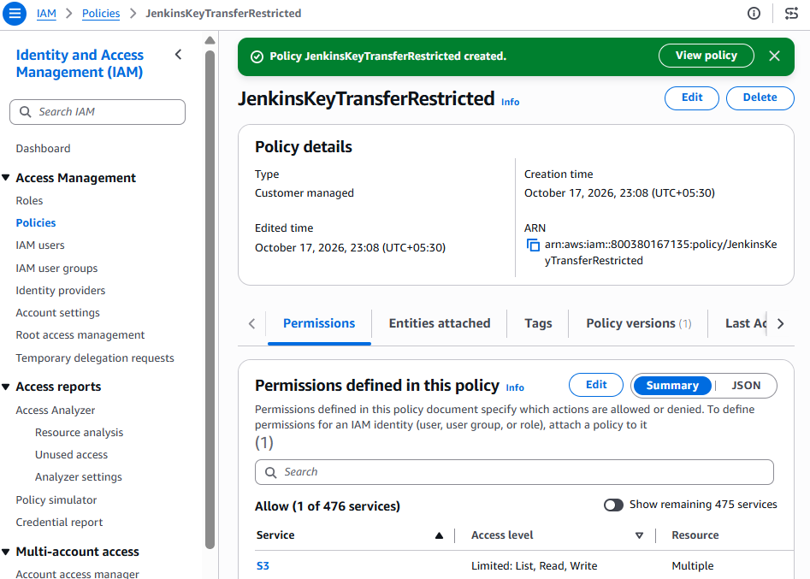
Step 7.13 — Create a dedicated IAM user
- In the AWS Console, open IAM → Users.
- Click Create user.
- Enter the username:
jenkins-key-transfer-temp
- Click Next.
- Select Attach policies directly.
- Search for JenkinsKeyTransferRestricted and select it.
- Click Next → Create user.
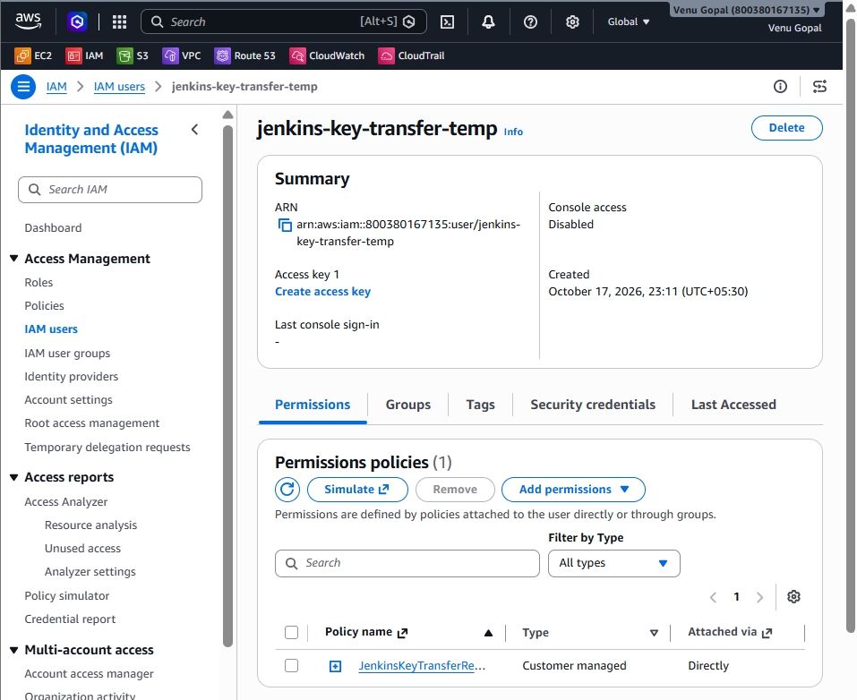
Step 7.14 — Create an access key for the temporary IAM user
We need Windows to upload the key to your private S3 bucket. This requires AWS credentials for the dedicated user.
- On the page shown, click Create access key.
- If prompted for a use case, select Command Line Interface (CLI).
- Acknowledge the recommendation if asked, then click Next.
- Add the description tag:
Temporary Jenkins PEM transfer
- Click Create access key.
- On the results page, keep the Access key ID and Secret access key available for the next step. Download the .csv file if the console offers it.
Security: These credentials can access objects in your temporary bucket. Do not paste either key into this chat or save them in a shared location.
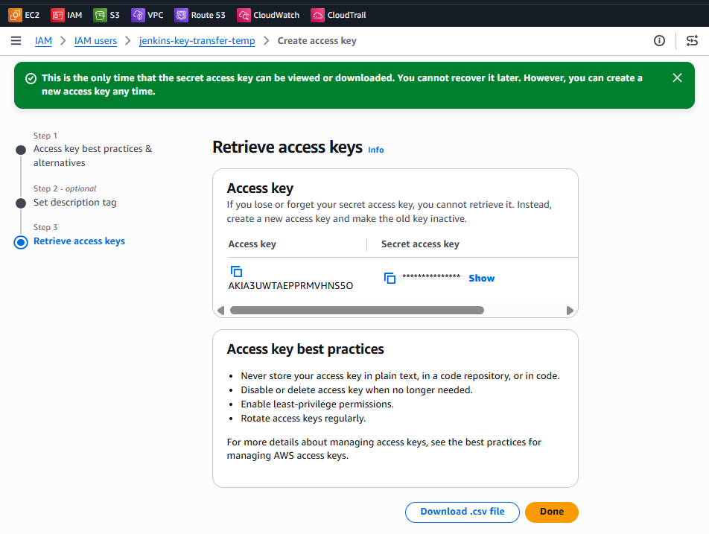
Step 7.15 — Configure the temporary AWS profile on Windows
Open PowerShell and run:
aws configure --profile jenkins-key-transfer-temp
Enter the values requested:
- AWS Access Key ID: enter the access key ID from Step 7.14.
- AWS Secret Access Key: enter the secret access key.
- Default region name: ap-south-1
- Default output format: json
Then verify that the profile uses the dedicated user:
aws sts get-caller-identity --profile jenkins-key-transfer-temp
The ARN should identify user/jenkins-key-transfer-temp, not root.
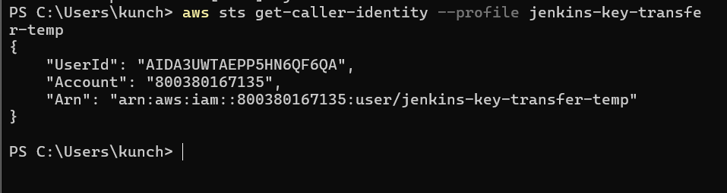
Step 7.16 — Verify access to your bucket
Run:
aws s3 ls s3://venu-jenkins-key-transfer-800380167135-20261017/ `
--region ap-south-1 `
--profile jenkins-key-transfer-temp
It should succeed and return an empty listing.
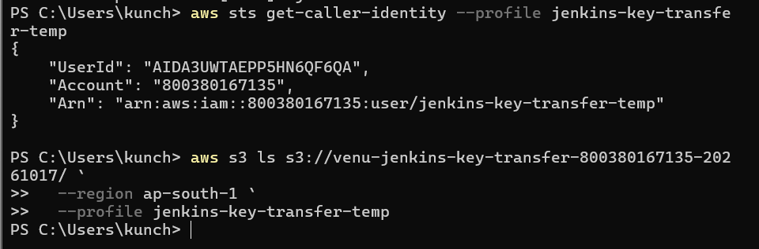
Upload Jenkins.pem to the private S3 bucket
In Windows PowerShell, run this exact command:
aws s3 cp "$env:USERPROFILE\Downloads\Jenkins.pem" `
s3://venu-jenkins-key-transfer-800380167135-20261017/Jenkins.pem `
--region ap-south-1 `
--profile jenkins-key-transfer-temp
If successful, you'll see an upload message.
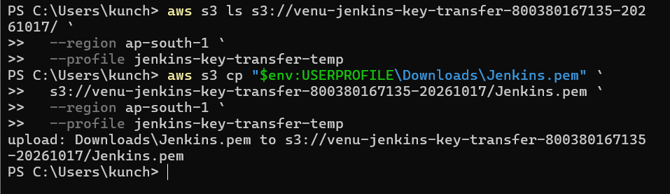
Step 7.17 — Verify the uploaded object
Run:
aws s3api head-object `
--bucket venu-jenkins-key-transfer-800380167135-20261017 `
--key Jenkins.pem `
--region ap-south-1 `
--profile jenkins-key-transfer-temp
This should return metadata, including the file size.
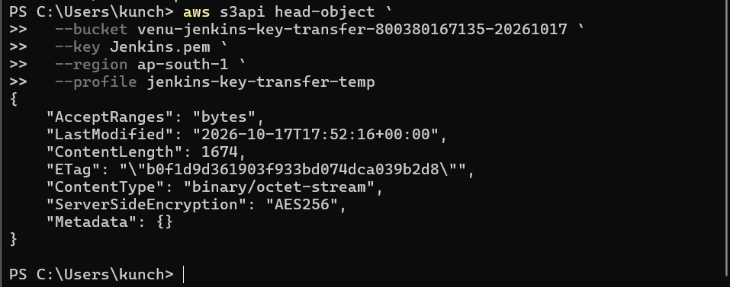
Step 7.18 — Download the key to your controller
Open your controller's AWS Console → EC2 → Connect → Session Manager terminal.
Run these exact commands:
1. Download the key
aws s3 cp \
s3://venu-jenkins-key-transfer-800380167135-20261017/Jenkins.pem \
/home/ec2-user/Jenkins.pem \
--region ap-south-1
2. Set secure file permissions
chmod 600 /home/ec2-user/Jenkins.pem
3. Move the key into the SSH directory
mkdir -p /home/ec2-user/.ssh
mv /home/ec2-user/Jenkins.pem /home/ec2-user/.ssh/Jenkins.pem
chmod 700 /home/ec2-user/.ssh
chmod 600 /home/ec2-user/.ssh/Jenkins.pem
4. Verify the file
ls -l /home/ec2-user/.ssh/Jenkins.pem
Expected permissions should begin with:
-rw-------
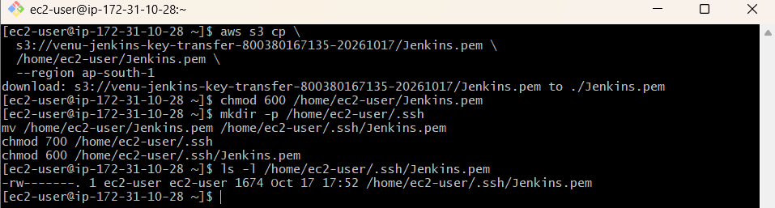
Step 7.19 — Delete the temporary S3 object
After the controller successfully downloads the key, return to Windows PowerShell and run:
aws s3 rm s3://venu-jenkins-key-transfer-800380167135-20261017/Jenkins.pem `
--region ap-south-1 `
--profile jenkins-key-transfer-temp
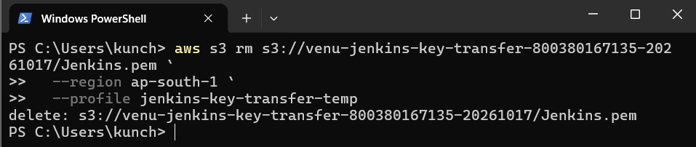
Step 7.20 — Test SSH to the backend
Run this exact command on the controller's Session Manager terminal:
ssh -i ~/.ssh/Jenkins.pem \
-o ConnectTimeout=10 \
-o StrictHostKeyChecking=accept-new \
ubuntu@13.232.3.128 'hostname'
If the public IP times out, try the backend's private IP, 172.31.15.197:
ssh -i ~/.ssh/Jenkins.pem \
-o ConnectTimeout=10 \
-o StrictHostKeyChecking=accept-new \
ubuntu@172.31.15.197 'hostname'
Expected result: A hostname such as ip-172-31-15-197.ap-south-1.compute.internal.
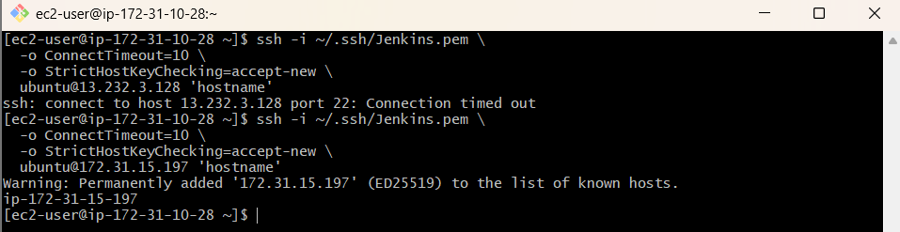
Step 7.21 — Update Terraform inventory
1. Open the Terraform directory
cd ~/nginx-netdata-ci/terraform
vi instances.tf
2. Find the local_file "ansible_inventory" resource and update it to:
resource "local_file" "ansible_inventory" {
filename = "${path.module}/../ansible/inventory.ini"

content = <<-EOT
[frontend]
c8.local ansible_host=${aws_instance.frontend.private_ip} ansible_user=ec2-user

[backend]
u21.local ansible_host=${aws_instance.backend.private_ip} ansible_user=ubuntu

[all:vars]
ansible_python_interpreter=auto_silent
EOT
}
Save with Esc, type :wq, and press Enter.
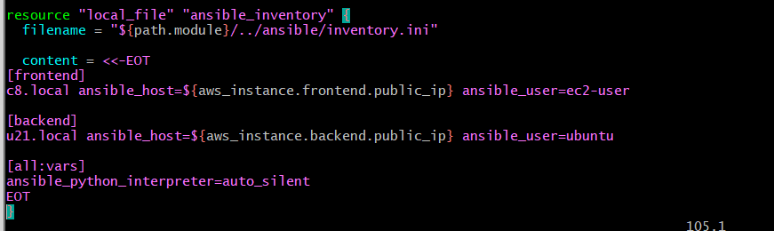
Step 7.22 — Validate Terraform
terraform fmt
terraform validate
terraform plan
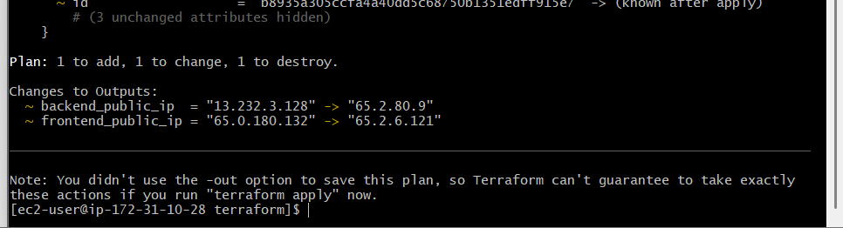
Review the plan before applying. If there are no unexpected infrastructure changes, run:
terraform apply
Type yes when prompted.
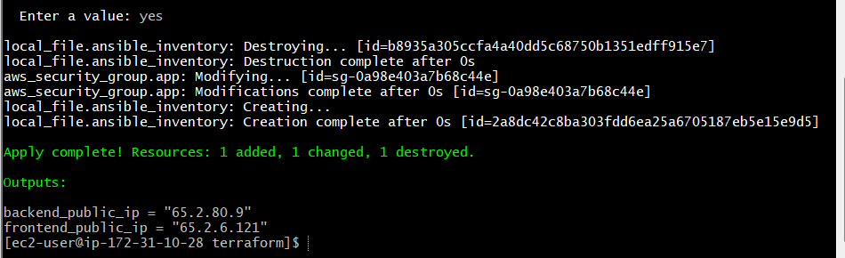
Step 7.23 — Verify the inventory
cat ../ansible/inventory.ini
Expected inventory:
[frontend]
c8.local ansible_host=172.31.13.16 ansible_user=ec2-user

[backend]
u21.local ansible_host=172.31.15.197 ansible_user=ubuntu

[all:vars]
ansible_python_interpreter=auto_silent
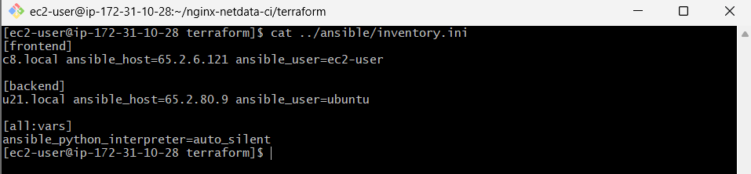
Step 7.24 — Fix the generated inventory
Run these commands from your current terraform directory.
1. Check the current private IPs from Terraform:
terraform output
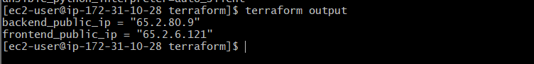
2. Find the inventory resource in instances.tf:
grep -n -A15 'local_file.*ansible_inventory' instances.tf
If that doesn't show the resource, run:
grep -n -A20 'ansible_inventory' instances.tf
3. Update the inventory template so the two ansible_host values use private IP attributes:
ansible_host=${aws_instance.frontend.private_ip}
ansible_host=${aws_instance.backend.private_ip}
Save the file,
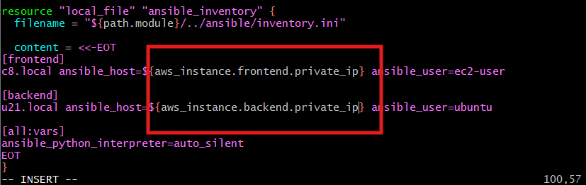then run:
terraform fmt
terraform validate
terraform plan
Review the plan. If it shows only the expected inventory update and no unexpected infrastructure changes, apply it:
terraform apply
Type yes when prompted.
4. Verify the inventory:
cat ../ansible/inventory.ini
It should contain private IPs like 172.31.x.x, not public IPs like 65.2.x.x.
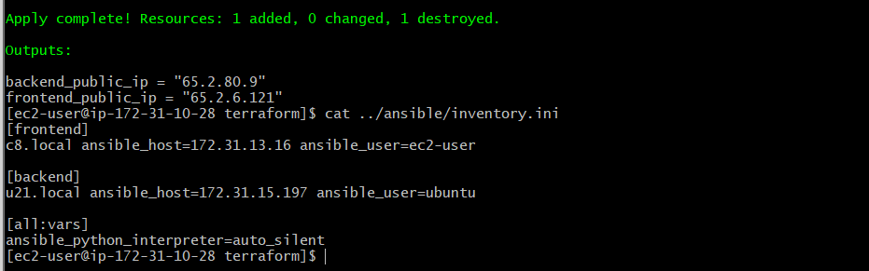
Step 7.25 — Install Ansible on the controller
Run these commands on your Amazon Linux controller:
1. Install Ansible
sudo dnf install -y ansible-core
2. Verify installation
ansible --version
3. Check the inventory
cd ~/nginx-netdata-ci/ansible
ansible-inventory -i inventory.ini --list
4. Test SSH connectivity to both servers
ansible all -i inventory.ini \
--private-key ~/.ssh/Jenkins.pem \
-m ping
Expected result: both c8.local and u21.local return "ping": "pong".
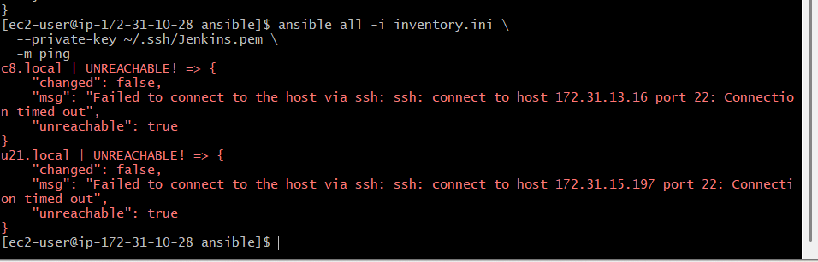
Step 7.26 — Check SSH connectivity
1. Test port 22 from the controller
Run:
timeout 5 bash -c '</dev/tcp/172.31.13.16/22' \
&& echo "Frontend SSH reachable" \
|| echo "Frontend SSH blocked"

timeout 5 bash -c '</dev/tcp/172.31.15.197/22' \
&& echo "Backend SSH reachable" \
|| echo "Backend SSH blocked"
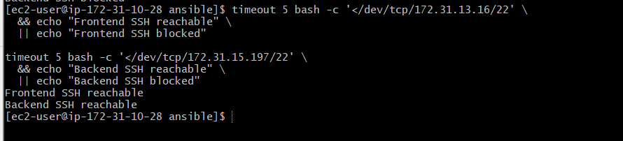
2. Check the security group
In the AWS Console:
- Go to EC2 → Instances.
- Select the frontend instance and open Security.
- Click its security group.
- Open Inbound rules → Edit inbound rules.
- Verify this rule exists:
Type | Port | Source
SSH | 22 | 172.31.10.28/32
Your controller's private IP is 172.31.10.28. Both target instances use the lab security group, so this rule should allow SSH from the controller over private IPs.
If the rule is missing, add it and save. Don't open SSH to 0.0.0.0/0.
3. Retry Ansible
Back in the controller terminal:
cd ~/nginx-netdata-ci/ansible

ansible all -i inventory.ini \
--private-key ~/.ssh/Jenkins.pem \
-m ping
Expected result:
c8.local | SUCCESS => {"ping": "pong"}
u21.local | SUCCESS => {"ping": "pong"}
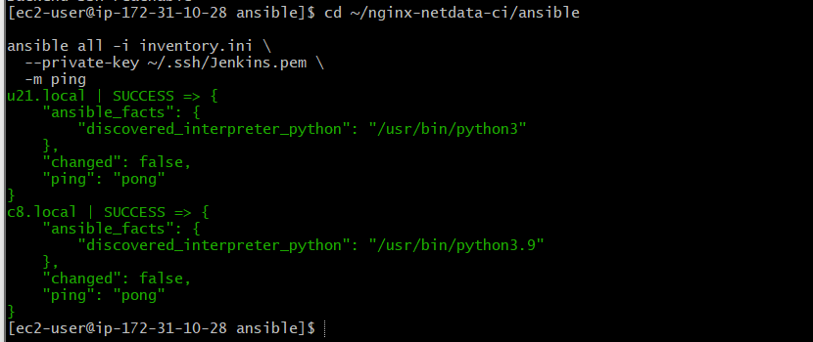
Step 7.27 — Verify both servers with Ansible
Run this command from your current ~/nginx-netdata-ci/ansible directory:
ansible all -i inventory.ini \
--private-key ~/.ssh/Jenkins.pem \
-m command -a "hostname"
You should see a hostname returned for both servers.
Step 7.28 — Check operating systems
ansible all -i inventory.ini \
--private-key ~/.ssh/Jenkins.pem \
-m command -a "cat /etc/os-release"
This confirms which operating system each host is running before we configure the services.
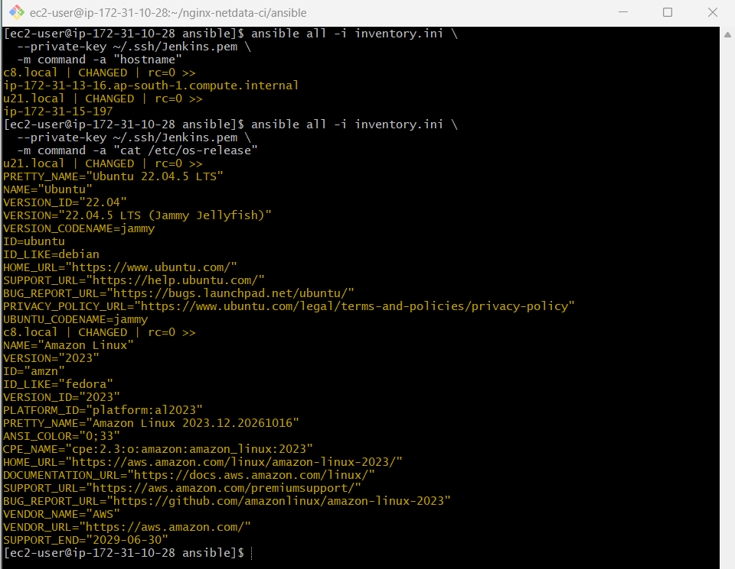
Step 7.29 — Create the Netdata and Nginx playbook
We'll install Netdata on the Ubuntu backend and Nginx on the Amazon Linux frontend.
1. Create the playbook
Run on the controller:
cd ~/nginx-netdata-ci/ansible
vi install-services.yml
Paste this content:
---
- name: Install Netdata on Ubuntu backend
hosts: backend
become: true

tasks:
- name: Update apt cache
ansible.builtin.apt:
update_cache: true
cache_valid_time: 3600

- name: Install Netdata
ansible.builtin.apt:
name: netdata
state: present

- name: Enable and start Netdata
ansible.builtin.service:
name: netdata
state: started
enabled: true

- name: Install Nginx on Amazon Linux frontend
hosts: frontend
become: true

tasks:
- name: Install Nginx
ansible.builtin.dnf:
name: nginx
state: present

- name: Enable and start Nginx
ansible.builtin.service:
name: nginx
state: started
enabled: true
Save using Esc, then :wq, then Enter.
2. Run the playbook
ansible-playbook -i inventory.ini \
--private-key ~/.ssh/Jenkins.pem \
install-services.yml
3. Verify both services
ansible backend -i inventory.ini \
--private-key ~/.ssh/Jenkins.pem \
-b -m command -a "systemctl is-active netdata"
ansible frontend -i inventory.ini \
--private-key ~/.ssh/Jenkins.pem \
-b -m command -a "systemctl is-active nginx"
Both should return active.
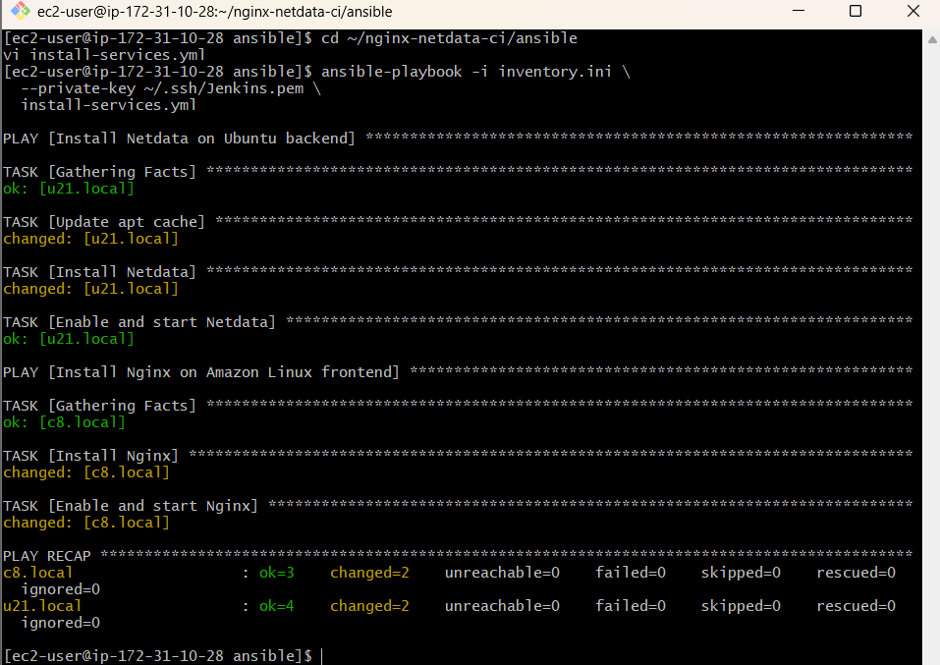
Step 7.30 — Configure Nginx as a reverse proxy
We'll configure the frontend to forward HTTP requests to Netdata on the backend.
1. Create the Nginx configuration playbook
cd ~/nginx-netdata-ci/ansible
vi configure-nginx.yml
Paste:
---
- name: Configure Nginx reverse proxy
hosts: frontend
become: true

tasks:
- name: Configure Nginx to proxy requests to Netdata
ansible.builtin.copy:
dest: /etc/nginx/conf.d/netdata.conf
owner: root
group: root
mode: "0644"
content: |
server {
listen 80 default_server;
server_name _;

location / {
proxy_pass http://172.31.15.197:19999;
proxy_http_version 1.1;
proxy_set_header Host $host;
proxy_set_header X-Real-IP $remote_addr;
proxy_set_header X-Forwarded-For $proxy_add_x_forwarded_for;
proxy_set_header X-Forwarded-Proto $scheme;
}
}

- name: Validate Nginx configuration
ansible.builtin.command: nginx -t
changed_when: false

- name: Restart Nginx
ansible.builtin.service:
name: nginx
state: restarted
enabled: true
Save with Esc, type :wq, and press Enter.
2. Run the playbook
ansible-playbook -i inventory.ini \
--private-key ~/.ssh/Jenkins.pem \
configure-nginx.yml
3. Test Netdata on the backend
ansible backend -i inventory.ini \
--private-key ~/.ssh/Jenkins.pem \
-m command -a "curl -s -o /dev/null -w '%{http_code}' http://127.0.0.1:19999/"
4. Test the frontend reverse proxy
ansible frontend -i inventory.ini \
--private-key ~/.ssh/Jenkins.pem \
-m command -a "curl -s -o /dev/null -w '%{http_code}' http://127.0.0.1/"
Both should ideally return an HTTP 200 response.
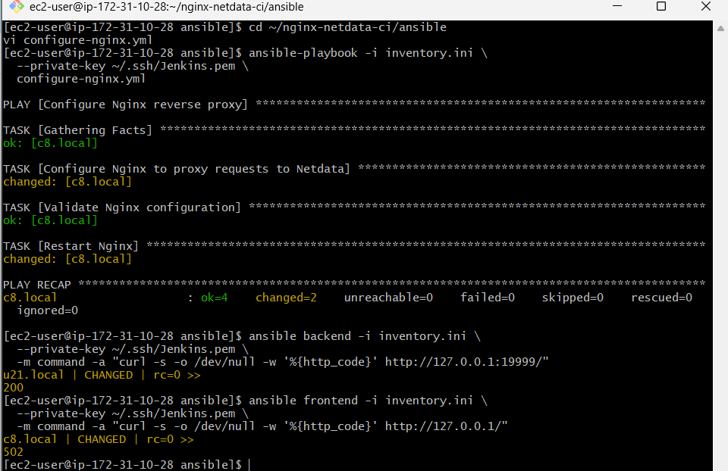
Step 7.31 — Check backend connectivity from the frontend
1. Test port 19999 from the frontend
Run this on the controller:
ansible frontend -i inventory.ini \
--private-key ~/.ssh/Jenkins.pem \
-m command -a "curl -v --connect-timeout 5 http://172.31.15.197:19999/"
2. Check what address Netdata listens on
ansible backend -i inventory.ini \
--private-key ~/.ssh/Jenkins.pem \
-b -m shell -a "ss -lntp | grep ':19999'"
Look at the Local Address:Port column. If Netdata listens only on 127.0.0.1:19999, the frontend cannot access it through the backend's private IP.
3. Check the backend security group
Your security group should allow inbound TCP port 19999 from its own security group (sg-0a98e403a7b68c44). Since both instances use that group, this should permit frontend-to-backend traffic.
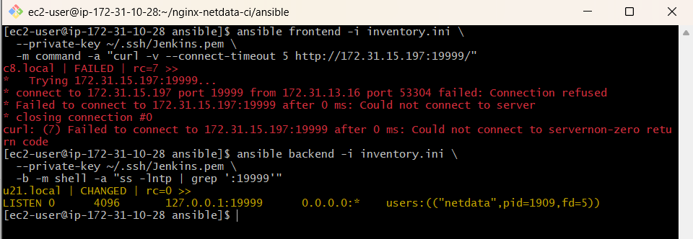
Step 7.32 — Fix configure-netdata.yml
1. Replace the playbook
Run:
cd ~/nginx-netdata-ci/ansible
vi configure-netdata.yml
Delete the existing contents and paste:
---
- name: Configure Netdata for frontend access
hosts: backend
become: true

tasks:
- name: Set Netdata listening address
ansible.builtin.shell: |
if [ ! -f /etc/netdata/netdata.conf ]; then
mkdir -p /etc/netdata
printf '[web]\n bind to = 172.31.15.197\n' > /etc/netdata/netdata.conf
elif grep -q '^[[:space:]]*bind to' /etc/netdata/netdata.conf; then
sed -i 's/^[[:space:]]*bind to.*/ bind to = 172.31.15.197/' /etc/netdata/netdata.conf
else
printf '\n[web]\n bind to = 172.31.15.197\n' >> /etc/netdata/netdata.conf
fi

- name: Restart Netdata
ansible.builtin.service:
name: netdata
state: restarted
enabled: true
Save with Esc, type :wq, and press Enter.
2. Run the playbook
ansible-playbook -i inventory.ini \
--private-key ~/.ssh/Jenkins.pem \
configure-netdata.yml
3. Verify Netdata's listening address
ansible backend -i inventory.ini \
--private-key ~/.ssh/Jenkins.pem \
-b -m shell -a "ss -lntp | grep ':19999'"
4. Test connectivity from the frontend
ansible frontend -i inventory.ini \
--private-key ~/.ssh/Jenkins.pem \
-m command -a "curl -s -o /dev/null -w '%{http_code}' --connect-timeout 5 http://172.31.15.197:19999/"
Expected HTTP status: 200.
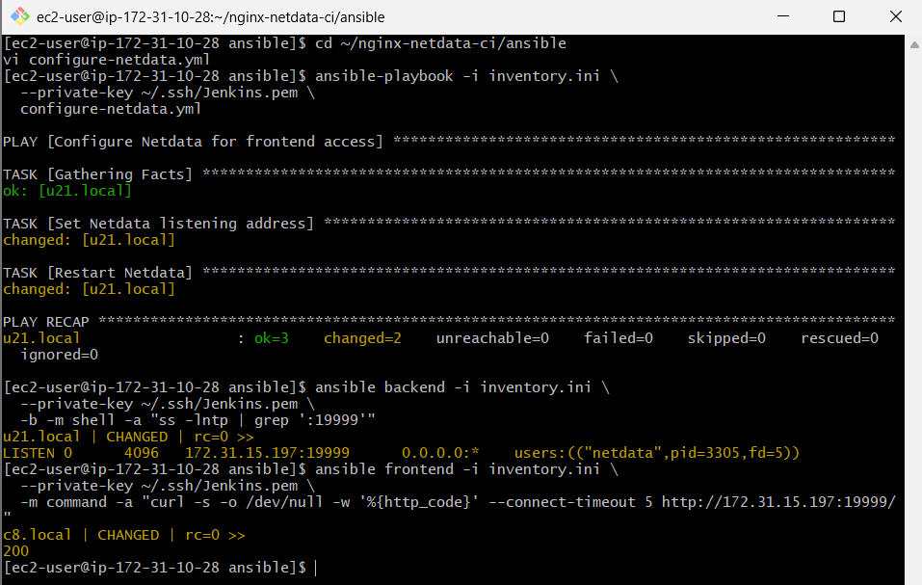

Step 7.33 — Retest the Nginx reverse proxy
Run this command on your controller:
ansible frontend -i inventory.ini \
--private-key ~/.ssh/Jenkins.pem \
-m command -a "curl -s -o /dev/null -w '%{http_code}' http://127.0.0.1/"
Expected output:
c8.local | CHANGED | rc=0 >>
200
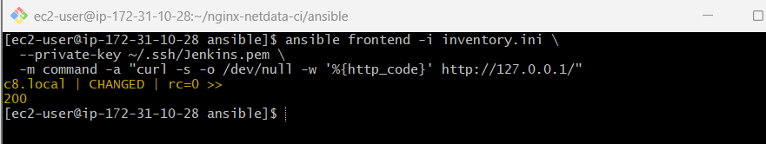
Step 7.34 — Test through the frontend public IP
Your current frontend public IP is 65.2.6.121.
Open this URL in your browser:
http://65.2.6.121
You should see the Netdata dashboard served through Nginx.
If the local proxy test still returns 502, run:
ansible frontend -i inventory.ini \
--private-key ~/.ssh/Jenkins.pem \
-b -m command -a "nginx -t"
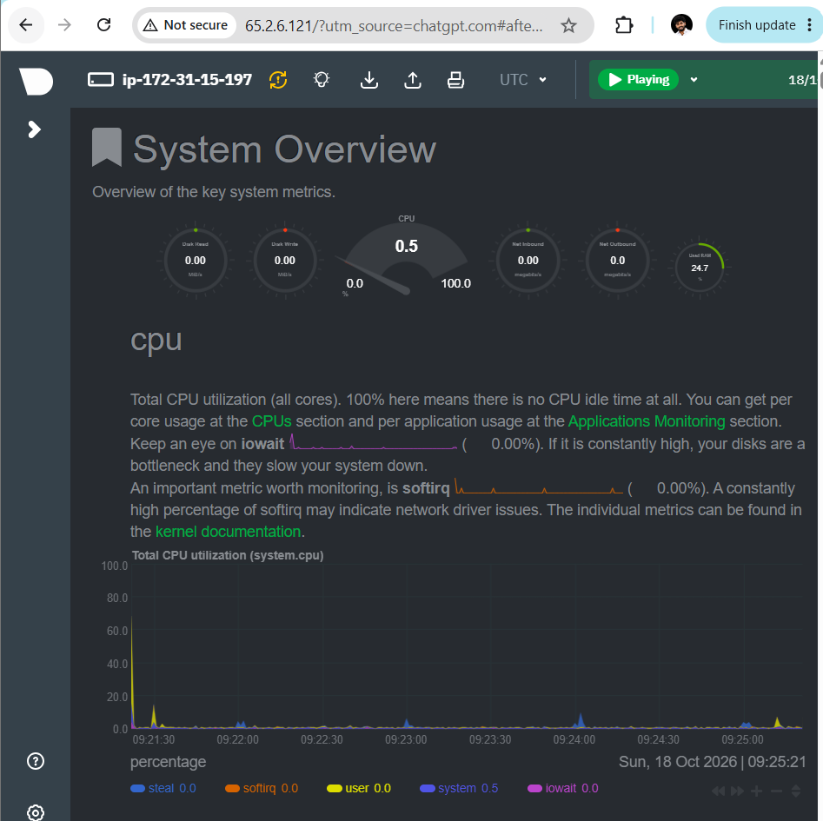
Step 7.35 — Save your completed lab status
Mama, run these commands to verify the services one final time:
cd ~/nginx-netdata-ci/ansible

ansible all -i inventory.ini \
--private-key ~/.ssh/Jenkins.pem \
-b -m shell \
-a "systemctl is-active nginx 2>/dev/null || systemctl is-active netdata"
This command checks for the named services on each host, but because Nginx and Netdata are on different hosts, the fallback behavior may vary. The clearer checks are:
ansible frontend -i inventory.ini --private-key ~/.ssh/Jenkins.pem -b -m command -a "systemctl is-active nginx"
ansible backend -i inventory.ini --private-key ~/.ssh/Jenkins.pem -b -m command -a "systemctl is-active netdata"
Both should return active.
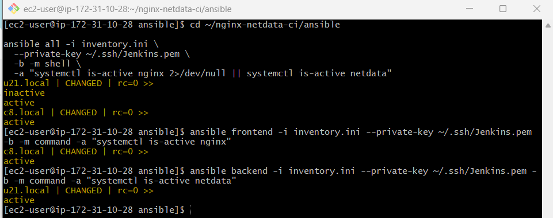

Challenge 2 — Jenkins CI/CD Pipeline
First, mama, run this command on your current controller to check whether Jenkins is installed:
sudo systemctl status jenkins --no-pager
- If it shows active (running), Jenkins is running on this controller.
- If it shows Unit jenkins.service could not be found, Jenkins is not installed as a system service here.
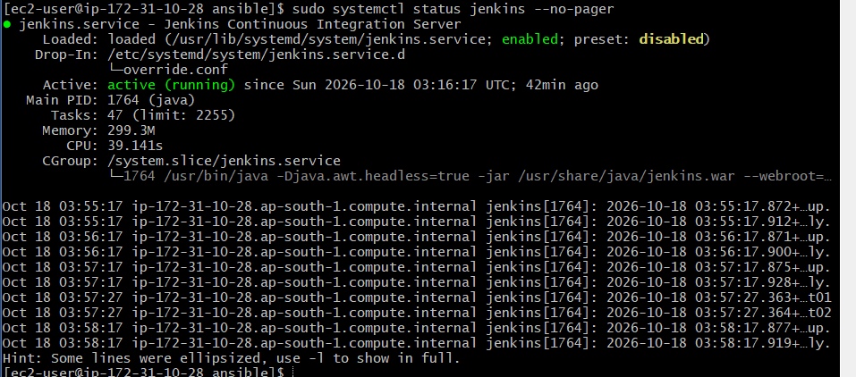
Step 2.1 — Verify Jenkins and required tools
Run these commands on your controller:
java -version
git --version
terraform -version
ansible --version
Next, check whether Jenkins can access its web interface locally:
curl -I http://localhost:8080
If your Jenkins uses a different port, check its configured port:
sudo systemctl cat Jenkins
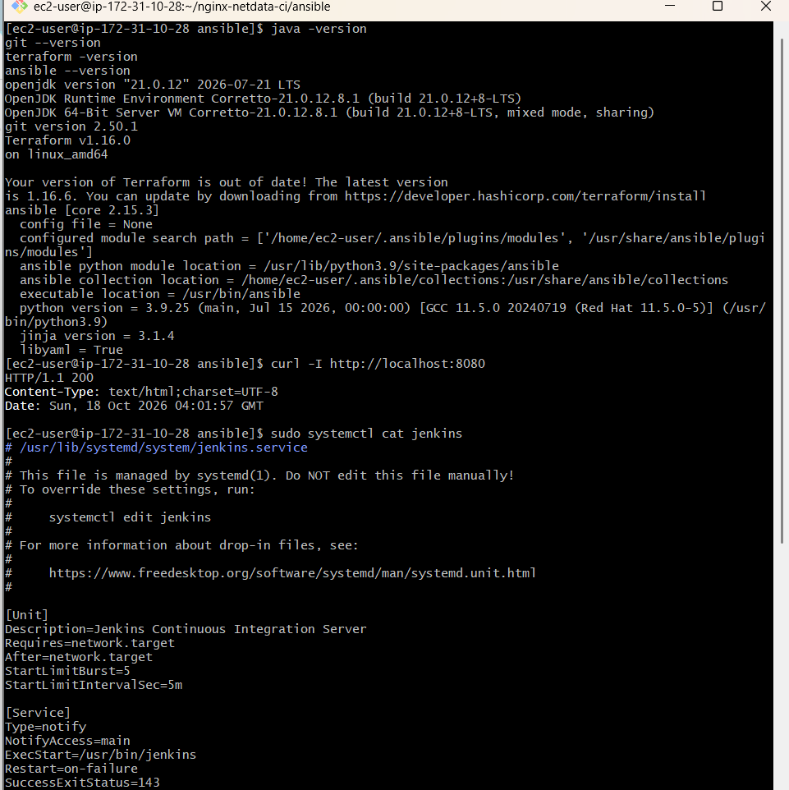
Step 2.2 — Prepare your project for Jenkins
Your project is already here:
~/nginx-netdata-ci/
├── terraform/
└── ansible/
Check the files:
cd ~/nginx-netdata-ci
find . -maxdepth 2 -type f
We need Jenkins to run Terraform and Ansible against your existing frontend and backend.
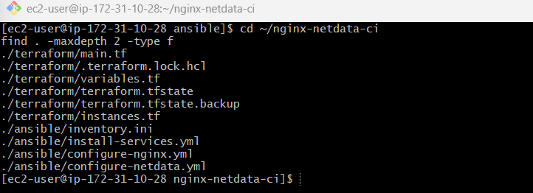
Step 2.3 — Prepare Jenkins access to your project
First, check which Linux user Jenkins runs as and whether it can access your project.
Run these commands on the controller:
sudo -u jenkins whoami
sudo -u jenkins ls -la /home/ec2-user/nginx-netdata-ci
sudo -u jenkins terraform -version
sudo -u jenkins ansible --version
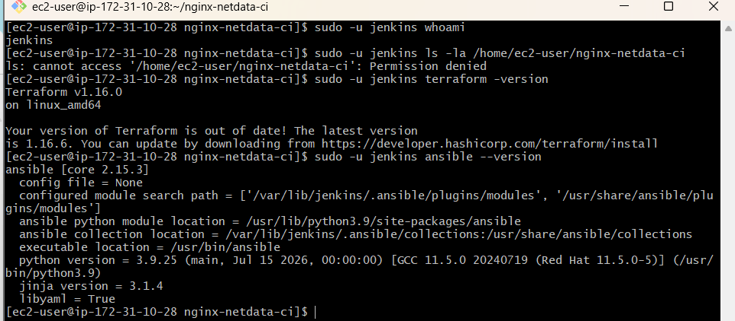
Step 2.4 — Copy the project to Jenkins
Run these commands on the controller.
1. Create a project directory for Jenkins
sudo mkdir -p /var/lib/jenkins/workspace/nginx-netdata-ci
2. Copy the Terraform and Ansible files
sudo cp -a ~/nginx-netdata-ci/terraform \
/var/lib/jenkins/workspace/nginx-netdata-ci/

sudo cp -a ~/nginx-netdata-ci/ansible \
/var/lib/jenkins/workspace/nginx-netdata-ci/
3. Give Jenkins ownership of the copied files
sudo chown -R jenkins:jenkins \
/var/lib/jenkins/workspace/nginx-netdata-ci
4. Verify access
sudo -u jenkins ls -la \
/var/lib/jenkins/workspace/nginx-netdata-ci
Expected folders:
ansible/
terraform/
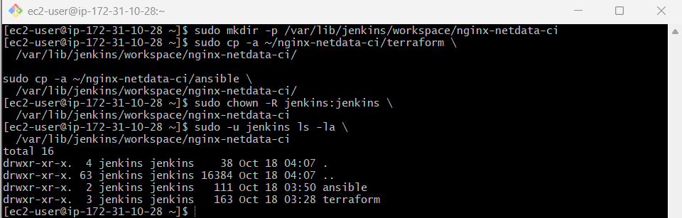
Step 2.5 — Check AWS access for Jenkins
Terraform will need AWS permissions when run by Jenkins. Check the controller's instance role credentials without printing any secrets:
sudo -u jenkins aws sts get-caller-identity
If you get command not found, run:
which aws
and send me the output.
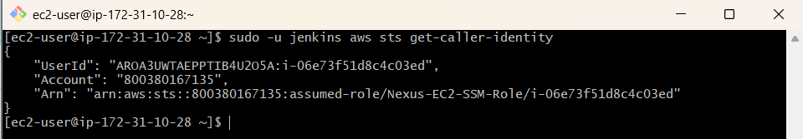
Step 2.6 — Verify Jenkins can access AWS and the project
Run these commands on your controller.
1. Check AWS access for Terraform:
cd /var/lib/jenkins/workspace/nginx-netdata-ci/terraform

sudo -u jenkins aws ec2 describe-instances \
--region ap-south-1 \
--query 'Reservations[].Instances[].InstanceId' \
--output table
2. Check Jenkins can read the Terraform configuration:
sudo -u jenkins terraform -chdir=/var/lib/jenkins/workspace/nginx-netdata-ci/terraform validate
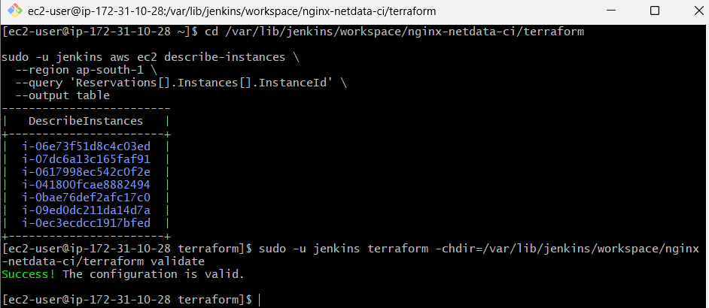
Step 2.7 — Check Terraform state
Run these commands from your current terminal:
sudo -u jenkins terraform -chdir=/var/lib/jenkins/workspace/nginx-netdata-ci/terraform state list
Then check whether Terraform is initialized:
ls -la /var/lib/jenkins/workspace/nginx-netdata-ci/terraform
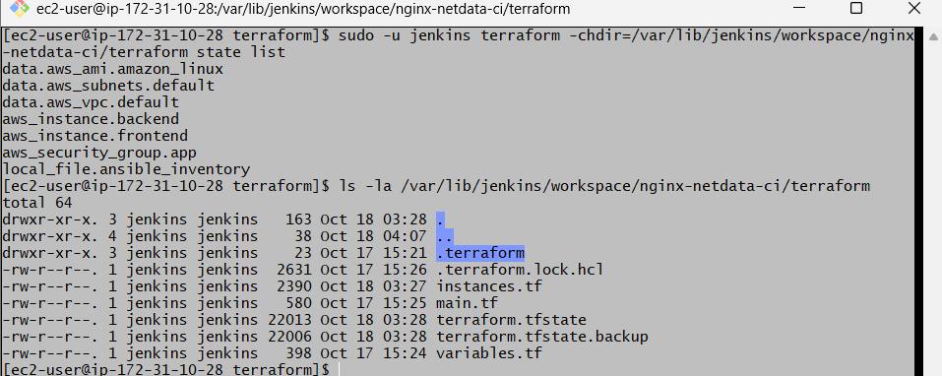
Step 2.8 — Create the Jenkinsfile
First, create the pipeline file in the project root.
cd /var/lib/jenkins/workspace/nginx-netdata-ci
sudo -u jenkins touch Jenkinsfile
sudo vi Jenkinsfile
Paste this pipeline:

pipeline {
agent any

options {
timestamps()
disableConcurrentBuilds()
}

environment {
TF_DIR = 'terraform'
ANSIBLE_DIR = 'ansible'
SSH_KEY = '/home/ec2-user/.ssh/Jenkins.pem'
}

stages {
stage('Checkout / Verify Project') {
steps {
sh '''
pwd
test -f terraform/main.tf
test -f terraform/terraform.tfstate
test -f ansible/inventory.ini
test -f ansible/install-services.yml
echo "Project files verified"
'''
}
}

stage('Terraform Format and Validate') {
steps {
dir('terraform') {
sh '''
terraform fmt -check
terraform validate
'''
}
}
}

stage('Terraform Plan') {
steps {
dir('terraform') {
sh '''
terraform plan -input=false -out=tfplan
'''
}
}
}

stage('Ansible Connectivity') {
steps {
dir('ansible') {
sh '''
ansible all -i inventory.ini \
--private-key "$SSH_KEY" \
-m ping
'''
}
}
}

stage('Verify Services') {
steps {
dir('ansible') {
sh '''
ansible frontend -i inventory.ini \
--private-key "$SSH_KEY" \
-b -m command \
-a "systemctl is-active nginx"

ansible backend -i inventory.ini \
--private-key "$SSH_KEY" \
-b -m command \
-a "systemctl is-active netdata"
'''
}
}
}
}
}
Save the file with Esc, type :wq, and press Enter.
Important before running the pipeline
The Jenkins service runs as the jenkins user, while your SSH key is currently under /home/ec2-user/.ssh/. The key may not be readable by Jenkins. Also, the pipeline deliberately does not run terraform apply; it creates a plan for review first.
Step 2.9 — Check the Jenkinsfile and SSH key access
Run:
sudo -u jenkins test -r /home/ec2-user/.ssh/Jenkins.pem \
&& echo "SSH key readable" \
|| echo "SSH key NOT readable"
Then:
sudo -u jenkins test -r /var/lib/jenkins/workspace/nginx-netdata-ci/Jenkinsfile \
&& echo "Jenkinsfile readable" \
|| echo "Jenkinsfile NOT readable"
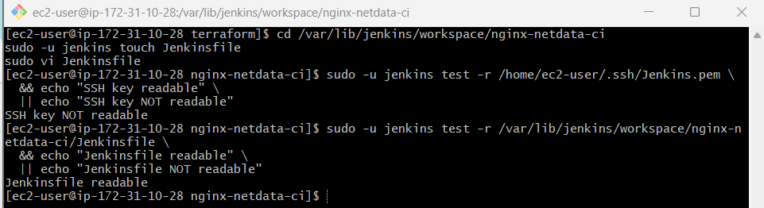
Step 2.10 — Copy the SSH key to Jenkins' private directory
Run these commands on the controller.
1. Create a secure SSH directory for Jenkins
sudo install -d -o jenkins -g jenkins -m 700 /var/lib/jenkins/.ssh
2. Copy the existing key
sudo install -o jenkins -g jenkins -m 600 \
/home/ec2-user/.ssh/Jenkins.pem \
/var/lib/jenkins/.ssh/Jenkins.pem
This preserves the original key and gives Jenkins its own restricted copy.
3. Verify the permissions
sudo -u jenkins test -r /var/lib/jenkins/.ssh/Jenkins.pem \
&& echo "Jenkins SSH key readable"
4. Test SSH as the Jenkins user
sudo -u jenkins ssh \
-i /var/lib/jenkins/.ssh/Jenkins.pem \
-o BatchMode=yes \
-o ConnectTimeout=10 \
ec2-user@172.31.13.16 'hostname'
Then test the Ubuntu backend:
sudo -u jenkins ssh \
-i /var/lib/jenkins/.ssh/Jenkins.pem \
-o BatchMode=yes \
-o ConnectTimeout=10 \
ubuntu@172.31.15.197 'hostname'
If either command reports a host-key verification error, don't disable host-key checking globally; send me the exact error.
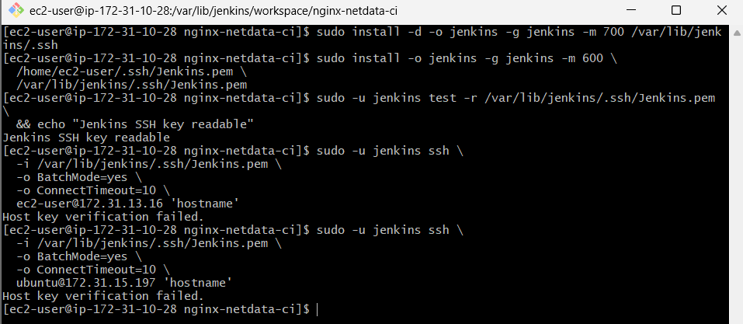
Step 2.11 — Update the Jenkinsfile SSH key path
Open the file:
sudo vi /var/lib/jenkins/workspace/nginx-netdata-ci/Jenkinsfile
Change:
SSH_KEY = '/home/ec2-user/.ssh/Jenkins.pem'
to:
SSH_KEY = '/var/lib/jenkins/.ssh/Jenkins.pem'
Save with Esc, :wq, and Enter.
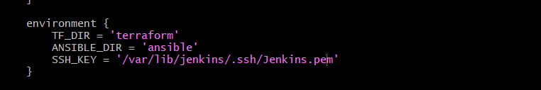
Step 2.12 — Fix the known_hosts file
1. Collect the host keys and write them with the correct permissions:
sudo ssh-keyscan -H 172.31.13.16 172.31.15.197 2>/dev/null \
| sudo tee /var/lib/jenkins/.ssh/known_hosts >/dev/null
2. Set ownership and permissions:
sudo chown jenkins:jenkins /var/lib/jenkins/.ssh/known_hosts
sudo chmod 600 /var/lib/jenkins/.ssh/known_hosts
3. Verify the file exists:
sudo -u jenkins test -s /var/lib/jenkins/.ssh/known_hosts \
&& echo "Known hosts configured"
Note: ssh-keyscan retrieves host keys but does not independently verify their identity. For production use, verify fingerprints through a trusted source.
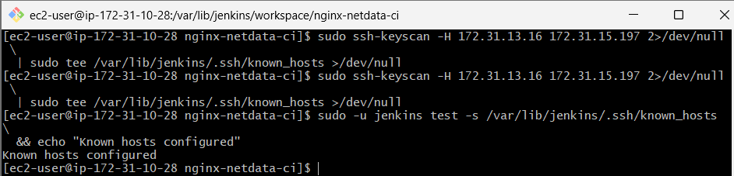
Step 2.13 — Retest SSH
Frontend:
sudo -u jenkins ssh \
-i /var/lib/jenkins/.ssh/Jenkins.pem \
-o BatchMode=yes \
-o ConnectTimeout=10 \
ec2-user@172.31.13.16 'hostname'
Backend:
sudo -u jenkins ssh \
-i /var/lib/jenkins/.ssh/Jenkins.pem \
-o BatchMode=yes \
-o ConnectTimeout=10 \
ubuntu@172.31.15.197 'hostname'
Both commands should print the respective hostnames.
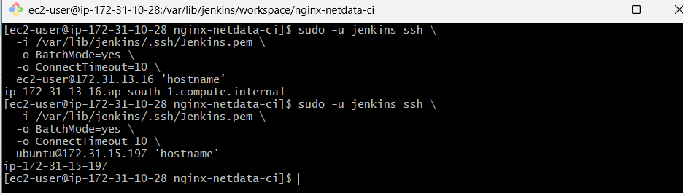
Next step: Update the Jenkinsfile SSH key path.
Run:
sudo vi /var/lib/jenkins/workspace/nginx-netdata-ci/Jenkinsfile
Change this line:
SSH_KEY = '/home/ec2-user/.ssh/Jenkins.pem'
to:
SSH_KEY = '/var/lib/jenkins/.ssh/Jenkins.pem'
Save and exit using Esc, then :wq.
Then verify the Jenkinsfile:
sudo grep SSH_KEY /var/lib/jenkins/workspace/nginx-netdata-ci/Jenkinsfile
It should display:
SSH_KEY = '/var/lib/jenkins/.ssh/Jenkins.pem'
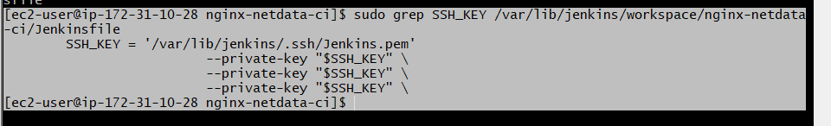
Next step: Verify the Jenkinsfile
Run this command:
sudo -u jenkins bash -c 'cd /var/lib/jenkins/workspace/nginx-netdata-ci && terraform -version'
If Terraform runs successfully, proceed to the Jenkins UI:
- Open http://13.203.193.26:8081
- Click New Item.
- Enter the job name nginx-netdata-ci.
- Select Pipeline and click OK.
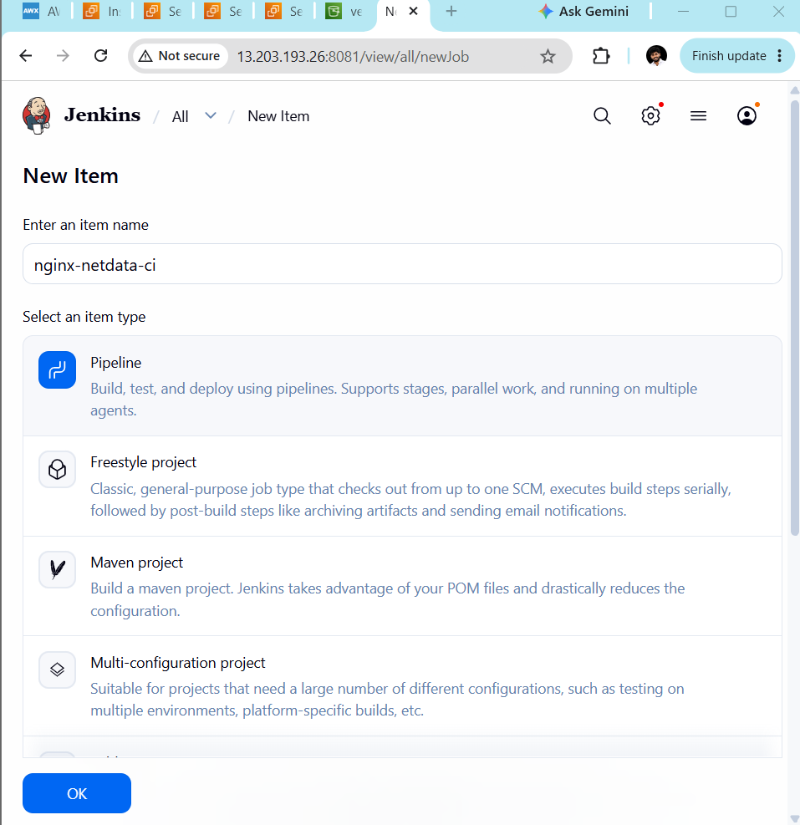
Step 1: Enter the pipeline script
- Keep Definition as Pipeline script.
- Uncheck Use Groovy Sandbox only if needed? Leave it checked for now.
- Paste the following script into the large Script box:

pipeline {
agent any

options {
timestamps()
disableConcurrentBuilds()
}

stages {
stage('Verify Project') {
steps {
sh '''
cd /var/lib/jenkins/workspace/nginx-netdata-ci
test -f terraform/main.tf
test -f terraform/terraform.tfstate
test -f ansible/inventory.ini
test -f ansible/install-services.yml
echo "Project files verified"
'''
}
}

stage('Terraform Format and Validate') {
steps {
dir('/var/lib/jenkins/workspace/nginx-netdata-ci/terraform') {
sh 'terraform fmt -check'
sh 'terraform validate'
}
}
}

stage('Terraform Plan') {
steps {
dir('/var/lib/jenkins/workspace/nginx-netdata-ci/terraform') {
sh 'terraform plan -input=false -lock=false'
}
}
}

stage('Ansible Connectivity') {
steps {
dir('/var/lib/jenkins/workspace/nginx-netdata-ci/ansible') {
sh '''
ansible all -i inventory.ini \
--private-key /var/lib/jenkins/.ssh/Jenkins.pem \
-m ping
'''
}
}
}

stage('Verify Services') {
steps {
dir('/var/lib/jenkins/workspace/nginx-netdata-ci/ansible') {
sh '''
ansible frontend -i inventory.ini \
--private-key /var/lib/jenkins/.ssh/Jenkins.pem \
-b -m command -a "systemctl is-active nginx"

ansible backend -i inventory.ini \
--private-key /var/lib/jenkins/.ssh/Jenkins.pem \
-b -m command -a "systemctl is-active netdata"
'''
}
}
}
}
}
Important: This pipeline runs a Terraform plan only; it does not apply infrastructure changes.
Step 2: Save
Click Save at the bottom-left.
Step 3: Run the build
- Click Build Now.
- Under Build History, click the new build number.
- Click Console Output.
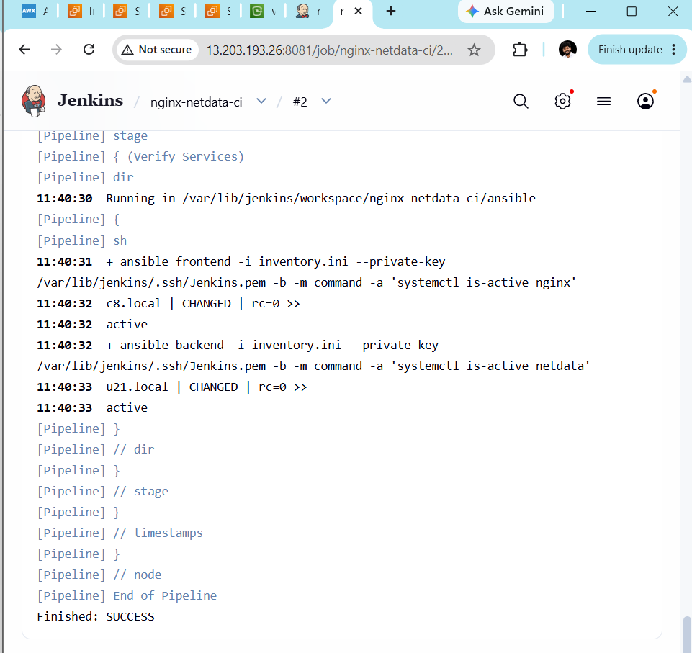
Verify Terraform inventory generation
Run this on your EC2 controller:
cd /home/ec2-user/nginx-netdata-ci

grep -n -A12 -B3 'local_file\|inventory' terraform/instances.tf
Then run:
cat /home/ec2-user/nginx-netdata-ci/ansible/inventory.ini
Your generated inventory should look similar to this:
[frontend]
c8.local ansible_host=172.31.13.16 ansible_user=ec2-user

[backend]
u21.local ansible_host=172.31.15.197 ansible_user=ubuntu

[all:vars]
ansible_python_interpreter=auto_silent
The IP addresses above are examples from your current setup; use the actual generated values.
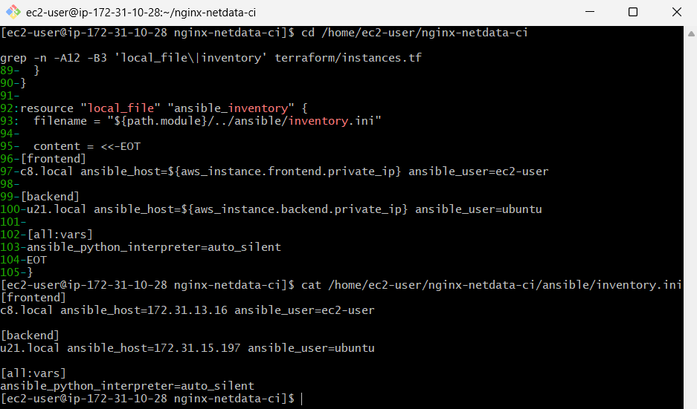
Final validation
To demonstrate that Terraform has recorded the inventory resource in its state, run:
cd /home/ec2-user/nginx-netdata-ci/terraform
terraform state show local_file.ansible_inventory
If it displays the resource and inventory content, that provides additional evidence.

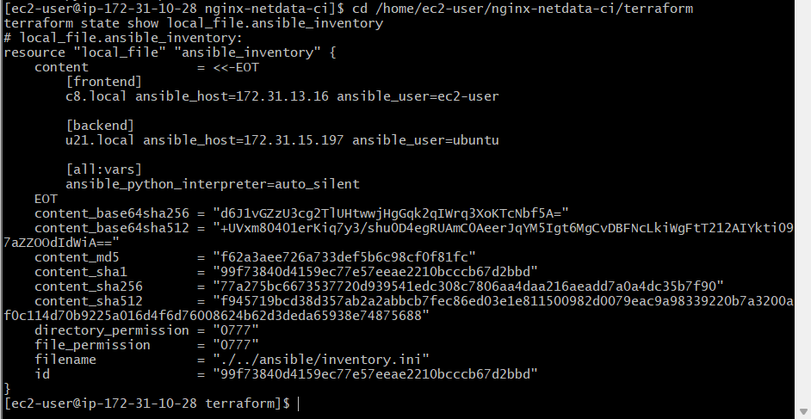

Challenge 3 — Create a Parameterized Jenkins Pipeline Job.
We previously worked on this challenge using the Spring MVC Maven application repository.
Challenge 3 requirements
Git branch selection
Choose the Git branch through a Jenkins build parameter named GIT_BRANCH.
Maven goals selection
Choose Maven goals through a parameter named MAVEN_GOALS.
Build and archive
Check out the selected branch, verify Java and Maven, run the selected Maven goals, and archive WAR artifacts.
Step 1 — Open Jenkins
Open Jenkins.
- Click New Item.
- Enter the job name:
challenge-3-parameterized-pipeline
- Select Pipeline.
- Click OK.
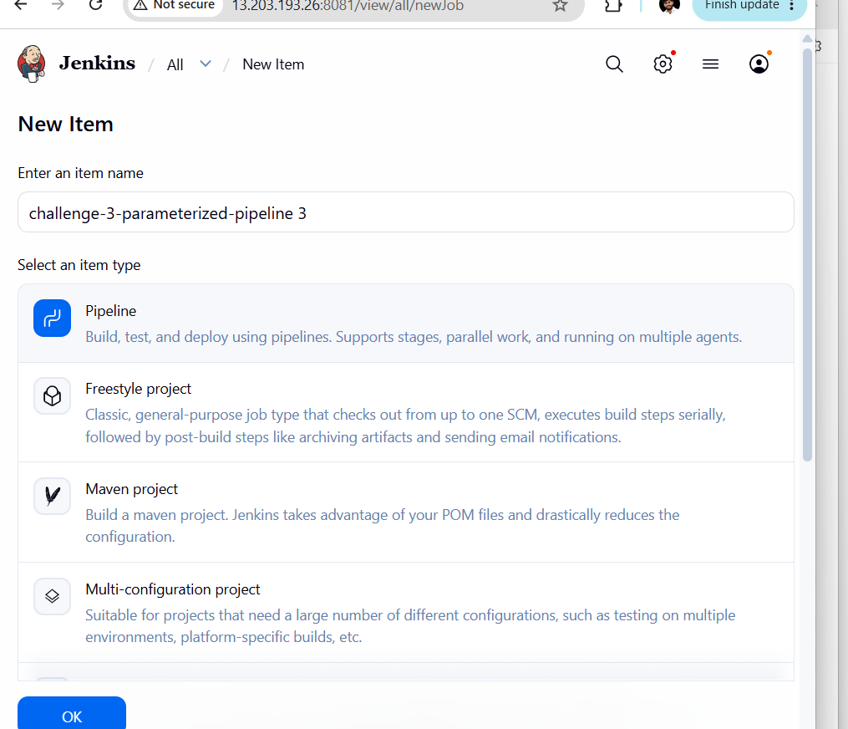
Step 2 — Configure parameters
On the configuration page, find This project is parameterized and check it.
Add these two Choice Parameter entries:
Name | Choices
GIT_BRANCH | main, master
MAVEN_GOALS | clean package, clean test, clean install
Set the description for each parameter if desired.
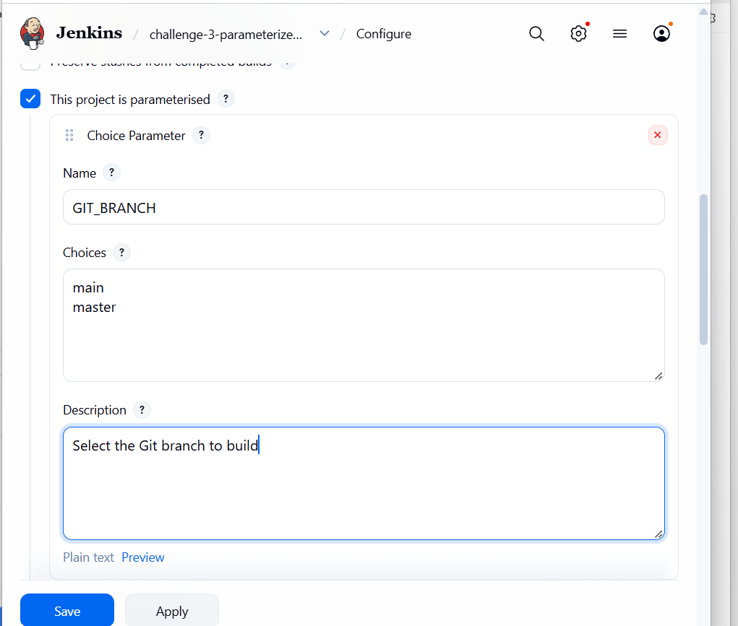
Step 2.3 — Add the second parameter
Click Add Parameter again → Choice Parameter.
Parameter 2: Maven goals
Name
MAVEN_GOALS
Choices — one per line
clean package clean test clean install
Copy choices
Description
Select the Maven goals to execute
Step 2.4 — Save
- Confirm both parameters appear under This project is parameterized.
- Scroll down and click Save.
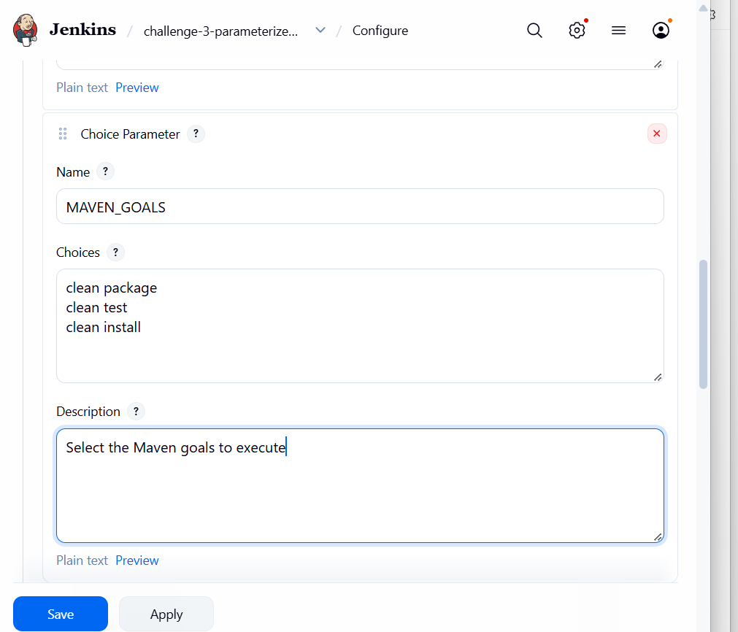
Step 3: Configure the Pipeline script
First, open your challenge-3-parameterized-pipeline job.
- Click Configure.
- Scroll down to the Pipeline section.
- Set Definition to Pipeline script.
- Paste this temporary validation pipeline into the Script box:

pipeline {
agent any

parameters {
choice(
name: 'GIT_BRANCH',
choices: ['main', 'master'],
description: 'Select Git branch'
)
choice(
name: 'MAVEN_GOALS',
choices: ['clean package', 'clean test', 'clean install'],
description: 'Select Maven goals'
)
}

stages {
stage('Verify Parameters') {
steps {
echo "Selected Git branch: ${params.GIT_BRANCH}"
echo "Selected Maven goals: ${params.MAVEN_GOALS}"
}
}

stage('Verify Java and Maven') {
steps {
sh '''
java -version
mvn -version
'''
}
}
}
}
Important, mama: This script repeats the two parameters you added in Step 2, so you should avoid duplicate definitions. Since you already configured them through This project is parameterized, remove the parameters { ... } block from this script before saving.
Then click Save.
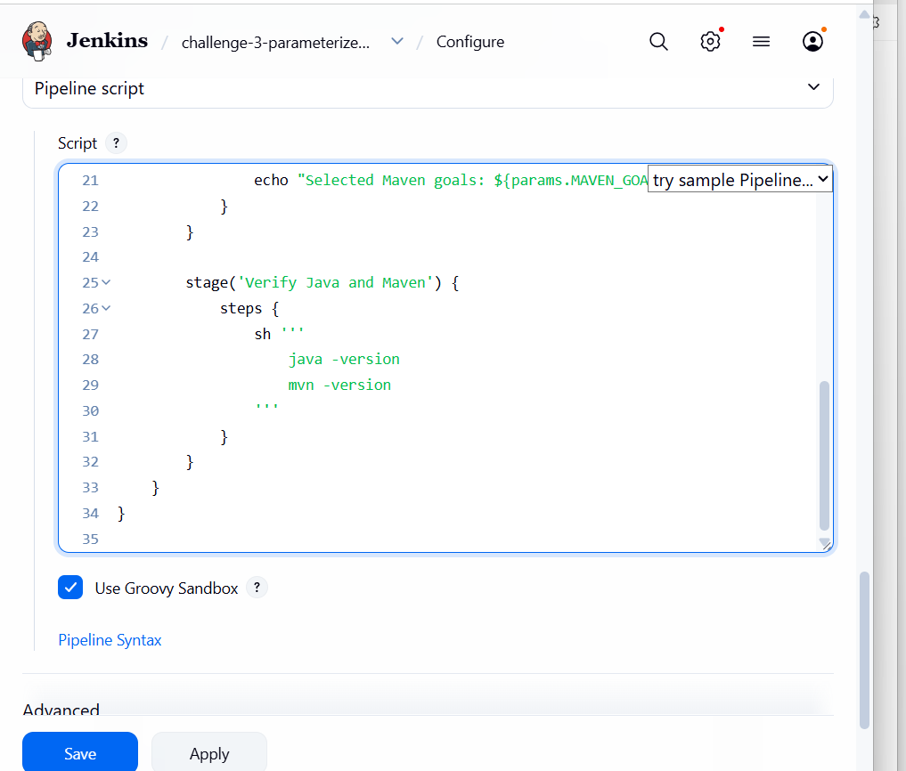
Step 4: Test the parameters
- Open the job page.
- Click Build with Parameters.
- Select your Git branch and Maven goals.
- Click Build.
- Open Console Output.
This is only a validation build. Once Java and Maven are verified, we'll configure the actual Git checkout and Maven build using your challenge's repository.
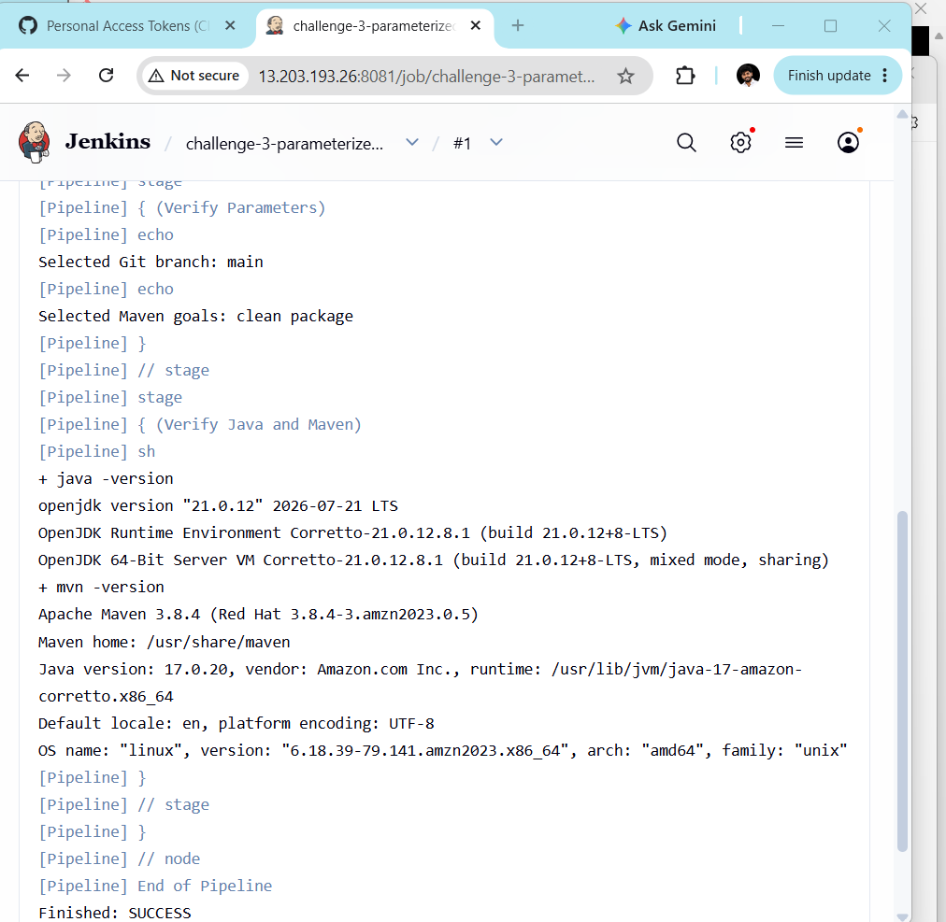
Step 5: Check the Ansible inventory
On your EC2 controller, run:
cd /home/ec2-user/nginx-netdata-ci/ansible
cat inventory.ini
Confirm that both groups exist:
[frontend]
c8.local ansible_host=172.31.13.16 ansible_user=ec2-user

[backend]
u21.local ansible_host=172.31.15.197 ansible_user=ubuntu
Use the actual IP addresses shown in your inventory if they differ.
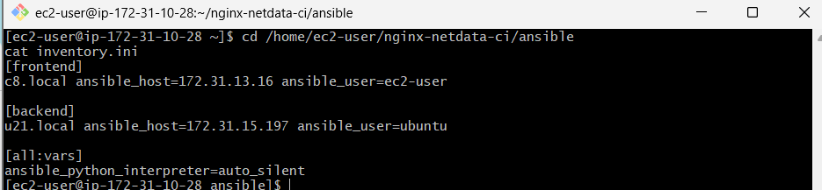
Step 6: Create the Ansible playbook
Run:
vi challenge3.yml
Paste this playbook for your current Amazon Linux frontend and Ubuntu backend:

---
- name: Configure Linux security services
hosts: all
become: true
tasks:
- name: Disable SELinux
ansible.posix.selinux:
state: disabled
when: ansible_os_family == "RedHat"

- name: Stop and disable firewalld if installed
ansible.builtin.service:
name: firewalld
state: stopped
enabled: false
failed_when: false
when: ansible_os_family == "RedHat"

- name: Install and configure Netdata on backend
hosts: backend
become: true
tasks:
- name: Install Netdata from Ubuntu repositories
ansible.builtin.apt:
name: netdata
state: present
update_cache: true

- name: Configure Netdata listening address
ansible.builtin.lineinfile:
path: /etc/netdata/netdata.conf
regexp: '^\s*#?\s*bind to\s*='
line: " bind to = {{ ansible_host }}"
notify: Restart Netdata

- name: Enable and start Netdata
ansible.builtin.service:
name: netdata
state: started
enabled: true

handlers:
- name: Restart Netdata
ansible.builtin.service:
name: netdata
state: restarted

- name: Install and configure Nginx on frontend
hosts: frontend
become: true
tasks:
- name: Install Nginx
ansible.builtin.dnf:
name: nginx
state: present

- name: Configure reverse proxy to backend Netdata
ansible.builtin.copy:
dest: /etc/nginx/conf.d/netdata.conf
mode: "0644"
content: |
server {
listen 80;
server_name c8.local;

location / {
proxy_pass http://{{ hostvars[groups['backend'][0]]['ansible_host'] }}:19999;
proxy_set_header Host $host;
proxy_set_header X-Real-IP $remote_addr;
proxy_set_header X-Forwarded-For $proxy_add_x_forwarded_for;
}
}
notify: Restart Nginx

- name: Enable and start Nginx
ansible.builtin.service:
name: nginx
state: started
enabled: true

handlers:
- name: Restart Nginx
ansible.builtin.service:
name: nginx
state: restarted
Save using Esc, then type :wq and press Enter.
Note: The playbook disables firewalld on Red Hat-family hosts, but does not disable Ubuntu's UFW. Disabling host firewalls reduces security; AWS security groups remain in effect. The SELinux task may require the ansible.posix collection and SELinux Python bindings.
Step 7: Validate the playbook
ansible-playbook -i inventory.ini challenge3.yml \
--syntax-check
Expected result:
playbook: challenge3.yml
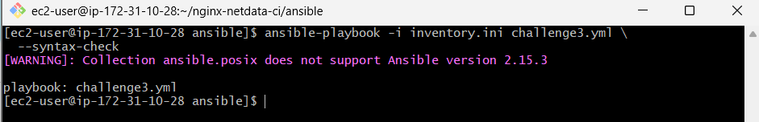
Step 8: Run the playbook
ansible-playbook -i inventory.ini challenge3.yml \
--private-key /home/ec2-user/.ssh/Jenkins.pem
If it fails, stop and send me the error output before retrying.
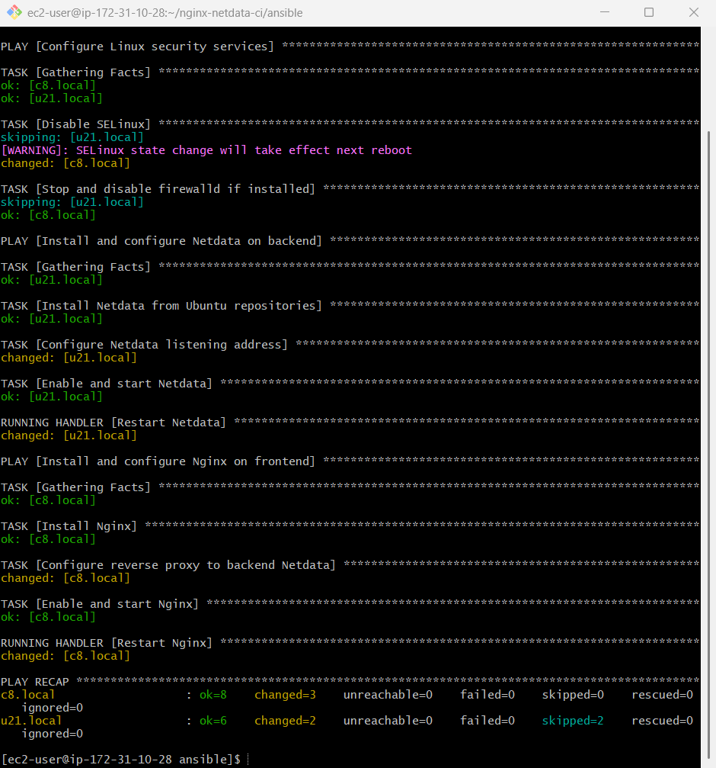
Step 9: Verify both services
ansible frontend -i inventory.ini \
--private-key /home/ec2-user/.ssh/Jenkins.pem \
-b -m command -a "systemctl is-active nginx"
ansible backend -i inventory.ini \
--private-key /home/ec2-user/.ssh/Jenkins.pem \
-b -m command -a "systemctl is-active netdata"
Both should return active.

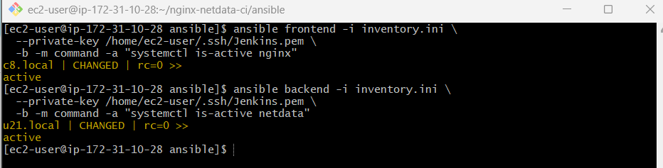
Step 10: Test the application
Open this address in your browser:
http://<FRONTEND_PUBLIC_IP>/
You should see the Netdata dashboard through Nginx.
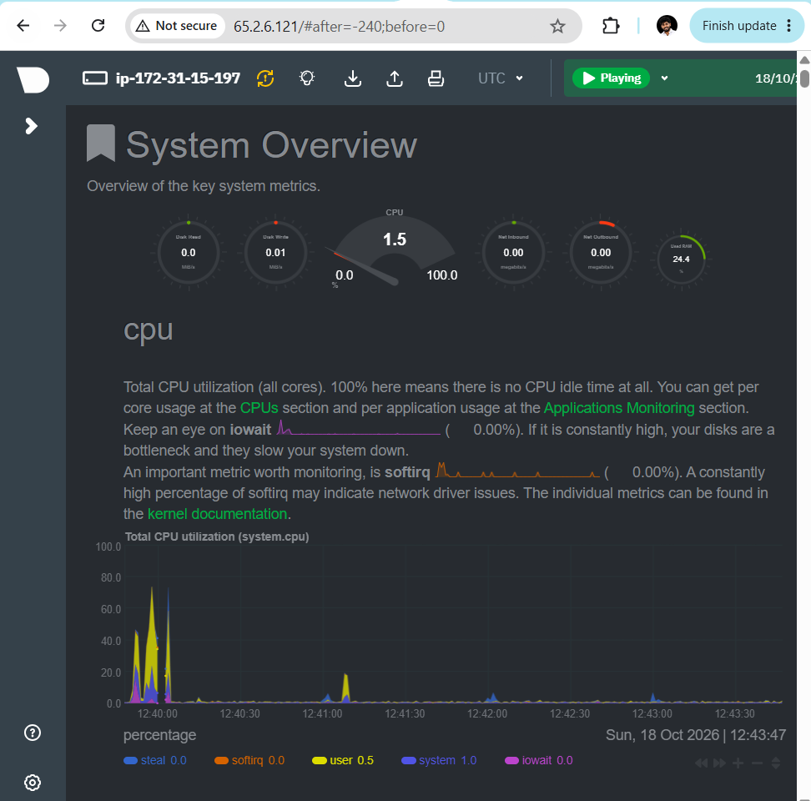
1. Verify Nginx on the frontend
ansible frontend -i inventory.ini \
--private-key /home/ec2-user/.ssh/Jenkins.pem \
-b -m command -a "systemctl is-enabled nginx"
Expected output: enabled
2. Verify Netdata on the backend
ansible backend -i inventory.ini \
--private-key /home/ec2-user/.ssh/Jenkins.pem \
-b -m command -a "systemctl is-enabled netdata"
Expected output: enabled
If both return enabled, your services are configured to start automatically after a reboot.
